
INDUSTRY REPORT
Information in the US
Nov 2025

About

IBISWorld
IBISWorld specializes in industry research with coverage on thousands of global industries. Our comprehensive data and in-depth analysis help businesses of all types gain quick and actionable insights on industries around the world. Busy professionals can spend less time researching and preparing for meetings, and more time focused on making strategic business decisions.

Table Of Contents | Standard

1. About 4
Codes 4
Definition 4
Related Terms 4
What's Included 5
Companies 5
Related Industries 5
Additional Resources 6
2. At a Glance 7
Key Takeaways 7
Products and Services 8
Major Players 9
Key External Drivers 10
Industry Structure 10
SWOT 11
Executive Summary 11
3. Performance 13
Highlights 13
Key Takeaways 13
Performance Snapshot 14
Outlook 25
Life Cycle 29
4. Products and Markets 30
Key Takeaways 30
Products and Services 31
Major Markets 37
International Trade 40
5. Geographic Breakdown 41
Key Takeaways 41
Business Locations 42
6. Competitive Forces 47
Key Takeaways 47
Concentration 47
Barriers to Entry 49
Substitutes 51
Buyer & Supplier Power 53
7. Companies 56
Key Takeaways 56
Market Share 57
Companies 58
8. External Environment 73
Key Takeaways 73
External Drivers 73
Regulation & Policy 76
Assistance 78
9. Financial Benchmarks 80
Key Takeaways 80
Cost Structure 80
Key Ratios 84
10. Key Statistics 86
Industry Data 86

1. About
https://my.ibisworld.com/us/en/industry/51/about

Codes
NAICS 2017 - USA | 51
NAICS 2022 - USA | 51

Definition
The Information sector includes businesses that produce and distribute information and cultural products, as well as provide the means for their distribution or process data. The sector includes telecommunications, data processing and hosting, print, online and software publishing, film, TV and record production and distribution, as well as TV and radio stations and networks. The sector does not include live entertainment.

Related Terms

BROADBAND
An internet connection with a minimum speed of 5.0 Mbps for downloads and 3.0 Mbps for uploads.

BUNDLED SERVICES
Bundled services include internet access and VoIP telephone service sold in combination with a cable TV subscription.

CIRCULATION
The number of copies of an average issue that a newspaper or periodical distributes.

CLOUD COMPUTING
A computing model in which storage and computing tasks are handled by networked machines (often servers in a data center owned by the service provider) rather than at the point of consumption.

INTERNET PROTOCOL
A communications protocol that allows data to be transmitted across network boundaries.

LONG-TERM EVOLUTION (LTE)
The successor technology to GSM, designed to operate on IP-based networks. LTE networks use a simpler, flat network architecture compared with GSM.

OPEN-SOURCE SOFTWARE (OSS)
Computer software distributed under a licensing arrangement and that allows computer codes to be shared, viewed and modified by other users and by organizations.

SOCIAL NETWORK
A category of website that is primarily used for communication and sharing with other members.

SOFTWARE AS A SERVICE (SAAS)
A model of software deployment where a provider licenses an application to customers for use as a service on demand.

VIDEO-ON-DEMAND (VOD)
An internet-based technology that allows subscribers to watch programming in real-time or download programs and view them later.

What's Included
- Providing telecommunication services
- Data processing and web publishing
- Software publishing
- Audio and video production and distribution
- Print publishing
- Pay TV programming
- Broadcasting

Companies
- Alphabet Inc.
- Verizon Communications Inc.
- Microsoft Corporation
- At&T Inc.
- Comcast Corporation
- Walt Disney Co

Related Industries

Industries in the Same Sector
- Competitors:
  - No data available
- Complementors:
  - No data available

International Industries
- Global Internet Service Providers

Additional Resources
- Federal Communications Commission
- International Telecommunications Union
- Software and Information Industry Association

2. At a Glance
https://my.ibisworld.com/us/en/industry/51/at-a-glance
Revenue  $2.5tr  ’20-’25 ↑ 2.4 %  ’25-’30 ↑ 2.4 % | Employees  4m  ’20-’25 ↑ 2.2 %  ’25-’30 ↑ 2.3 % | Businesses  510k  ’20-’25 ↑ 4.0 %  ’25-’30 ↑ 2.2 %
Profit  $313.7bn  ’20-’25 ↑ 2.0 % | Profit Margin  12.6%  ’20-’25 ↓ 0.3 pp | Wages  $619.1bn  ’20-’25 ↑ 2.8 %  ’25-’30 ↑ 2.3 %

Key Takeaways

Performance
- Macroeconomic trends are a big driver for growth in the Information sector. As more households and businesses are formed, they're subscribing to telecommunications and processing services, boosting the sector's expansion.
- 5G and streaming services are shaking up the media landscape, pushing traditional cable and print out of the spotlight. Companies are racing to deliver high-quality content and faster internet to capture consumers’ attention.
- AI and cloud solutions are revolutionizing data processing, publishing, and media industries. Businesses are leveraging these technologies for predictive analytics, personalized content, and operational efficiencies, setting new industry standards.

Products and Markets
- Telecommunications is struggling amidst changing consumer preferences. Younger households are ditching large cable packages and wired telephony, pushing the industry to adapt more to mobile and 5G technologies.
- Households are the largest single market in the information sector since most product and service offerings are geared toward consumers. The subsector most reliant on households is telecommunications, which is the final, consumer-facing step of many media distribution chains.
- The pandemic has supercharged growth in data processing and online publishing. With the skyrocketing demand for cloud-based products and digital advertising, these sectors have become key revenue drivers for the information sector.
- Print media revenues are being cannibalized by digital formats. As consumers and advertisers flock to precise and cost-effective online channels, traditional print publications can't keep up despite their digital editions.

Products and Services
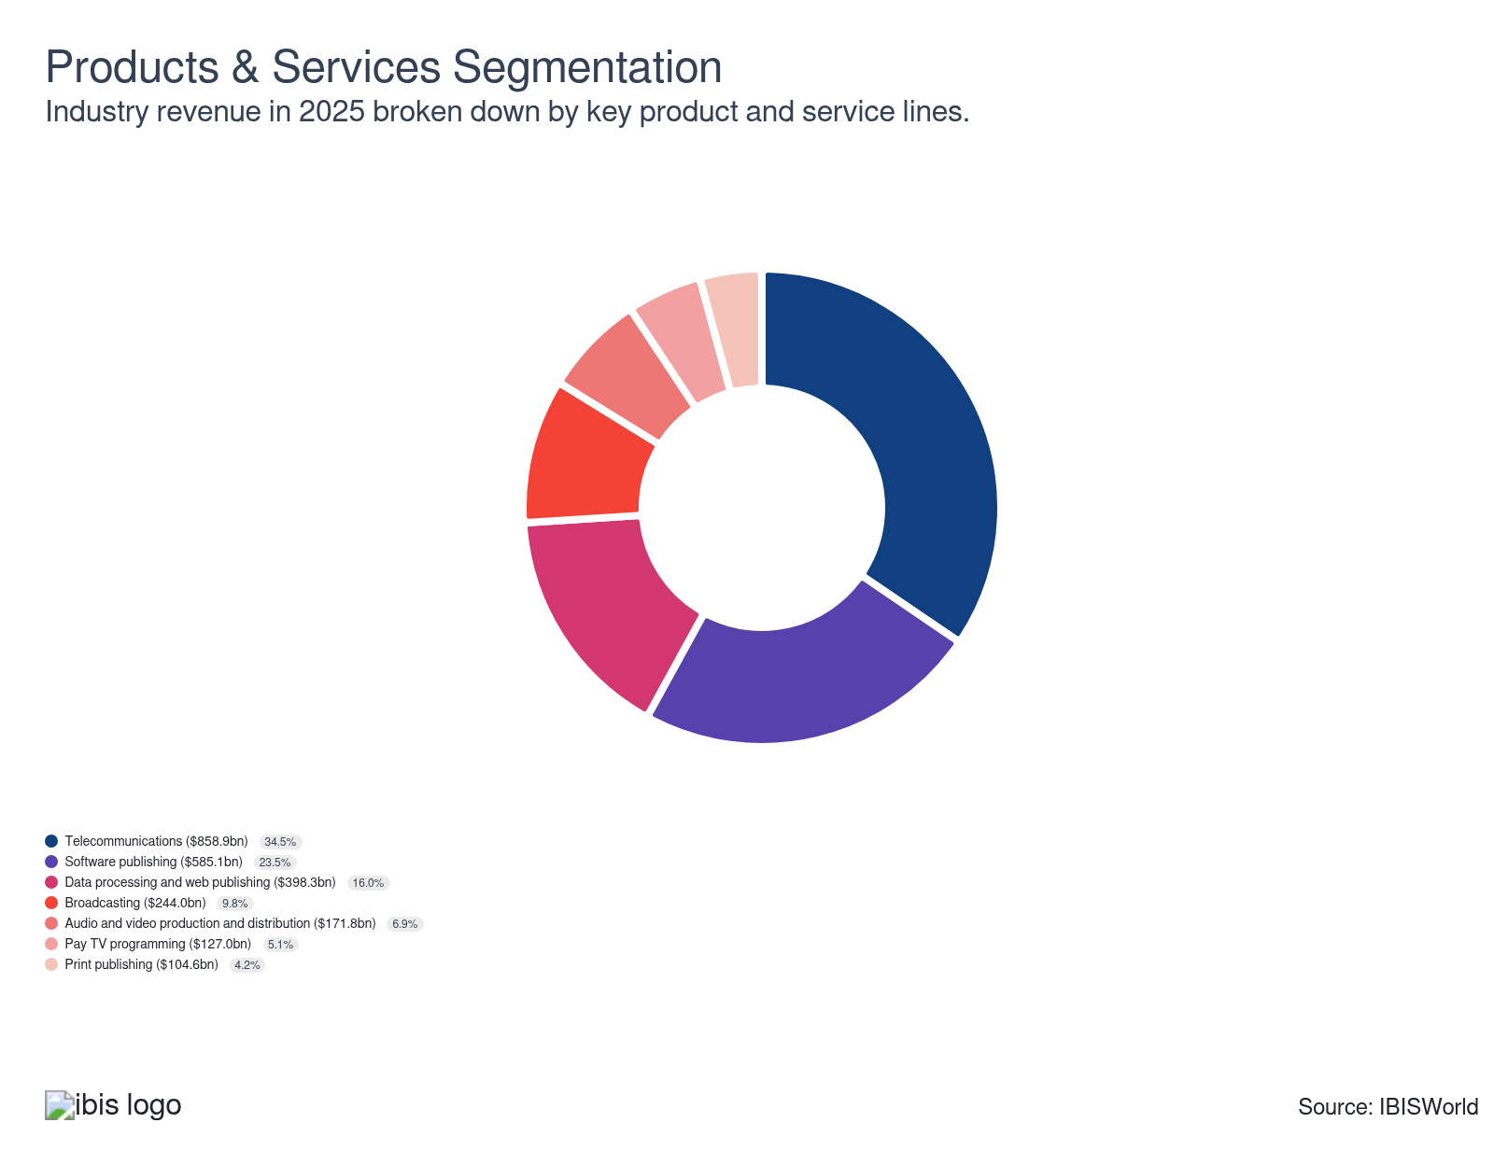

Major Players
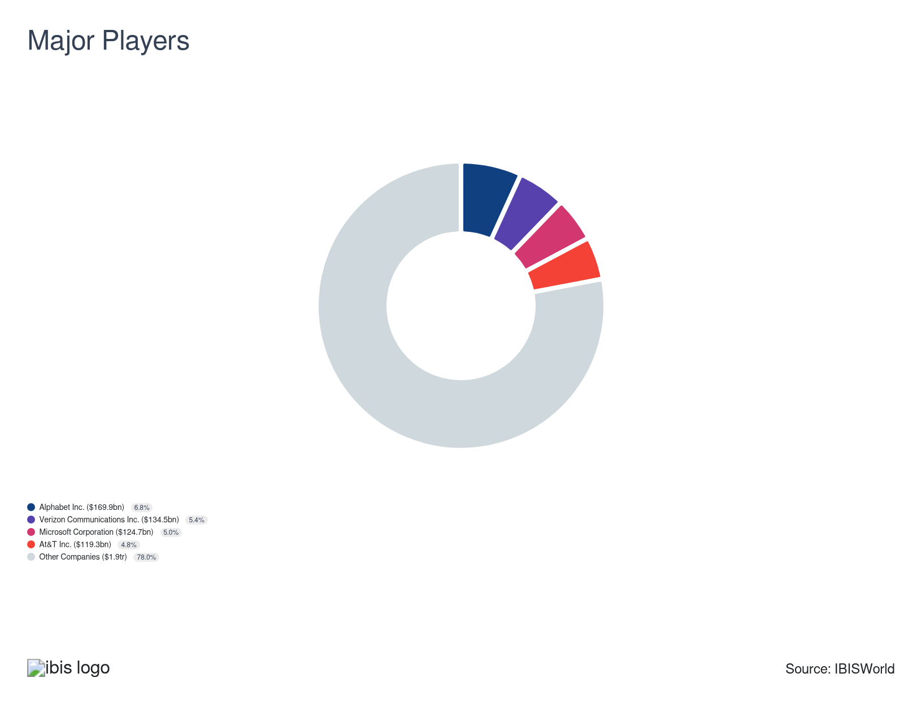

Key External Drivers
Key External Drivers | Impact
Households earning more than $100,000 | Positive
Number of mobile internet connections | Positive
Total advertising expenditure | Positive
Private investment in computers and software | Positive

Industry Structure
Characteristic | Level | Trend
Concentration | Low
Barriers To Entry | High | Steady
Regulation and Policy | Moderate | Decreasing
Life Cycle | Mature
Revenue Volatility | Moderate
Assistance | Low | Steady
Competition | High | Increasing
Innovation | High

SWOT
Strengths  Low Volatility  Low Customer Class Concentration  Low Product/Service Concentration  High Revenue per Employee | Weaknesses  Low Profit vs. Sector Average  High Capital Requirements | Opportunities  High Revenue Growth (2020-2025)  High Performance Drivers  Number of mobile internet connections | Threats  Low Revenue Growth (2005-2025)  Low Outlier Growth  Low Revenue Growth (2025-2030)  Private investment in computers and software

Executive Summary

For your information: Revenue for the sector will accelerate as the pandemic continues to abate
The Information sector creates and distributes media content to US consumers and businesses. The Information sector responds to trends in household formation, which influences subscription volumes to communications services and advertising expenditure, generating nearly one-fourth of sector revenue. Also, consumer incomes and spending habits influence the extent to which households purchase discretionary entertainment products. The Information sector also sells some products and services directly to businesses and is influenced to a lesser extent by trends in corporate profit and business sentiment. The accelerated pace of digital transformation has fueled industry growth. As remote work and online learning became the norm, demand for robust digital infrastructure and cloud services skyrocketed. This shift wasn't limited to cloud services alone; internet providers flourished, spurred by the advent of 5G technology. Through the end of 2025, sector revenue will expand at a CAGR of 2.4% to reach $2.5 trillion, including a boost of 2.0% in 2025 alone.
Although consumer demand for media is generally steady and the Information sector has expanded consistently, revenue flows within the sector are uneven and determined by technology trends. Substantial expansion through the end of 2025 has stemmed from a proliferation of new consumer devices. However, most of the expansion has been concentrated on online publishing and data processing at the expense of more traditional information subsectors. For example, new digital channels have detracted from print advertising expenditures, which have declined during the current period and contributed to the curtailment of print publishing. The expansion of mobile devices and the emergence of online streaming services have made consumers less reliant on traditional communication services, such as wired voice, broadband internet and cable TV.
Looking ahead, the information sector is poised for sustained growth over the next five years, fueled by rising consumer spending and private investment. As the economy recovers and interest rates stabilize, disposable incomes are poised to climb, allowing households to avail themselves of more digital subscriptions and services. The rollout of 5G will further augment mobile internet usage, potentially challenging wired broadband alternatives. Traditional media companies will continue to shift their focus to online platforms and streaming services, aiming to retain and expand their audience. Through the end of 2030, the Information sector revenue will strengthen at a CAGR of 2.4% to reach $2.8 trillion.

3. Performance
https://my.ibisworld.com/us/en/industry/51/performance

Highlights
Revenue  $2.5tr  2020-25 CAGR ↑ 2.4 %  2025-30 CAGR ↑ 2.4 % | Employees  4m  2020-25 CAGR ↑ 2.2 %  2025-30 CAGR ↑ 2.3 % | Businesses  510k  2020-25 CAGR ↑ 4.0 %  2025-30 CAGR ↑ 2.2 %
Profit  $313.7bn  2020-25 CAGR ↑ 2.0 % | Profit Margin  12.6%  2020-25 CAGR ↓ 0.3 pp

Key Takeaways
- Macroeconomic trends are a big driver for growth in the Information sector. As more households and businesses are formed, they're subscribing to telecommunications and processing services, boosting the sector's expansion.
- 5G and streaming services are shaking up the media landscape, pushing traditional cable and print out of the spotlight. Companies are racing to deliver high-quality content and faster internet to capture consumers’ attention.
- AI and cloud solutions are revolutionizing data processing, publishing, and media industries. Businesses are leveraging these technologies for predictive analytics, personalized content, and operational efficiencies, setting new industry standards.

Performance Snapshot
Revenue: | ↑ 2020-25 Revenue CAGR +2.4%
Revenue  $2.5tr  ’20-’25 ↑ 2.4 %  ’25-’30 ↑ 2.4 % | 2025 Revenue Growth  ↑ 2.1 % | Revenue Volatility  Moderate
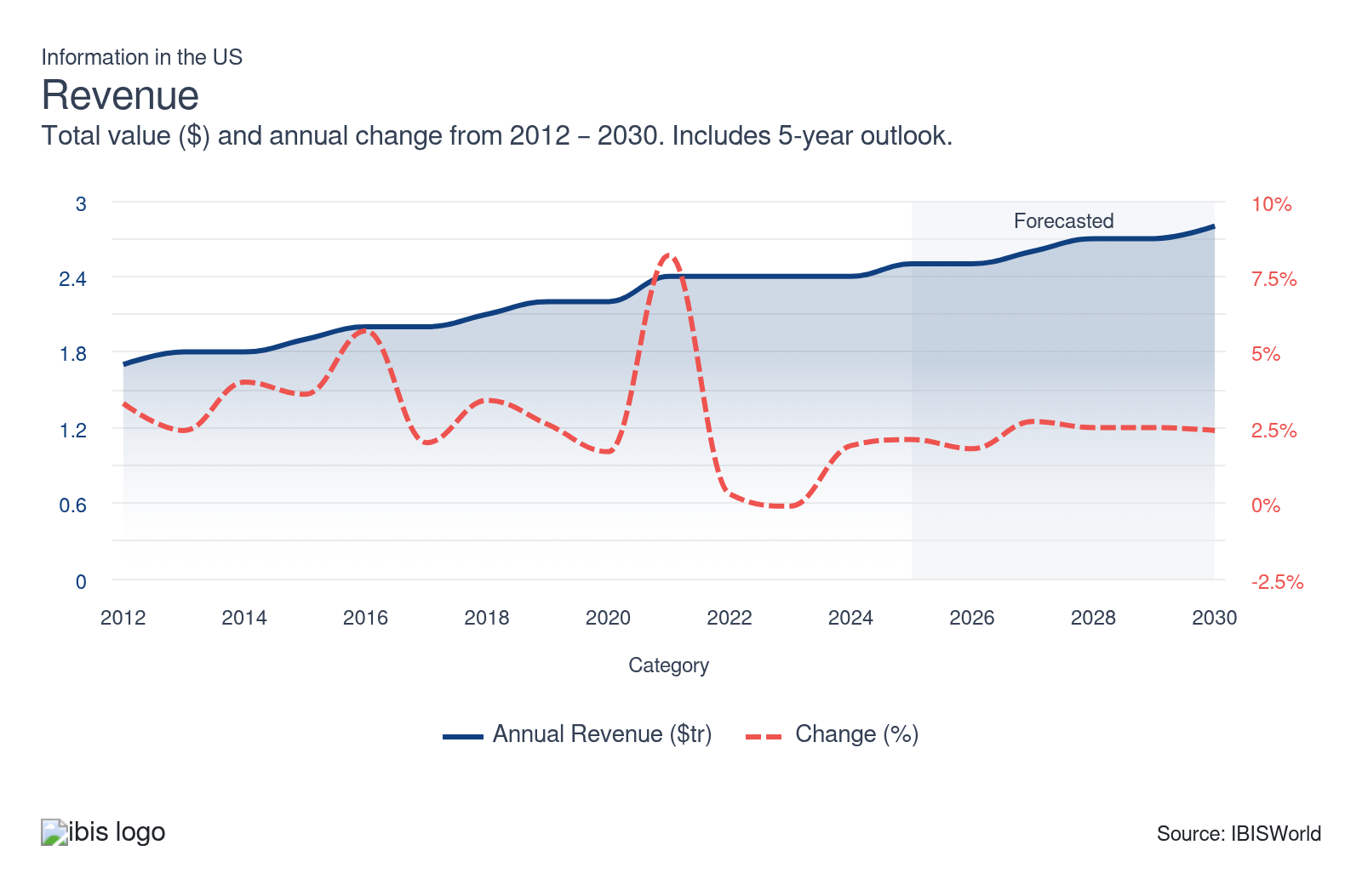
Employees: | ↑ 2020-25 Employees CAGR +2.2%
Employees  4m  ’20-’25 ↑ 2.2 %  ’25-’30 ↑ 2.3 % | Employees per Business  9  ’20-’25 ↓ 1.7 %  ’25-’30 ↑ 0.1 % | Revenue per Employee  $570k  ’20-’25 ↑ 0.2 %  ’25-’30 ↑ 0.1 %
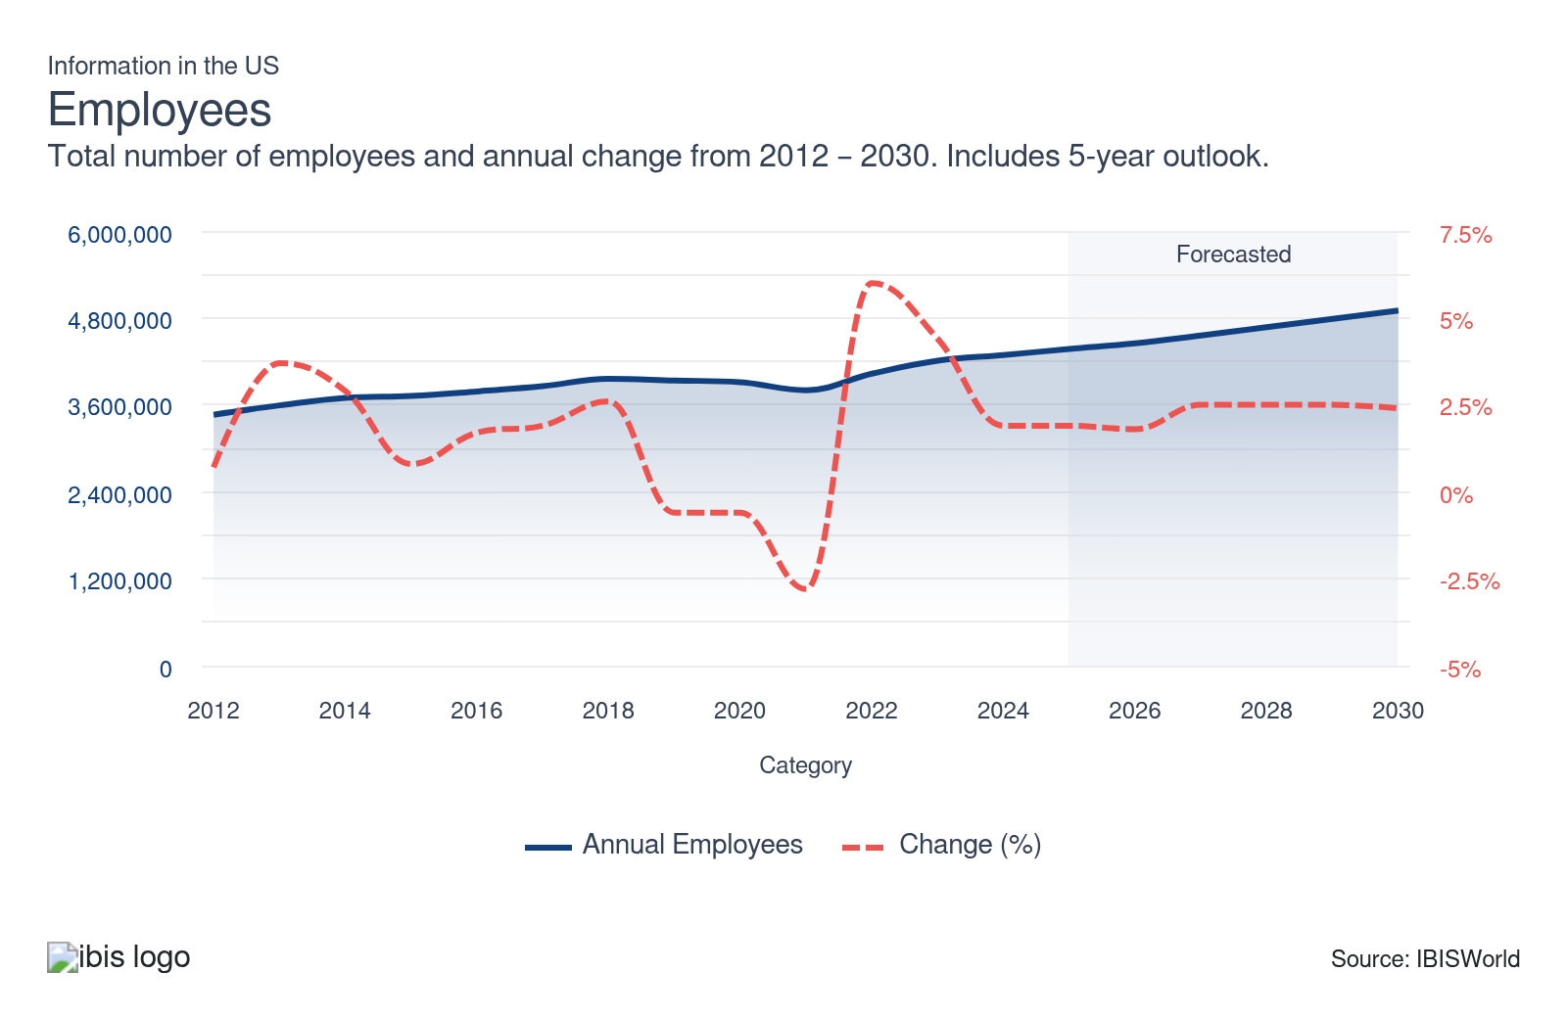
Businesses: | ↑ 2020-25 Business CAGR +4.0%
Businesses  510k  ’20-’25 ↑ 4.0 %  ’25-’30 ↑ 2.2 % | Employees per Business  9  ’20-’25 ↓ 1.7 %  ’25-’30 ↑ 0.1 % | Revenue per Business  $4.9m  ’20-’25 ↓ 1.5 %  ’25-’30 ↑ 0.2 %
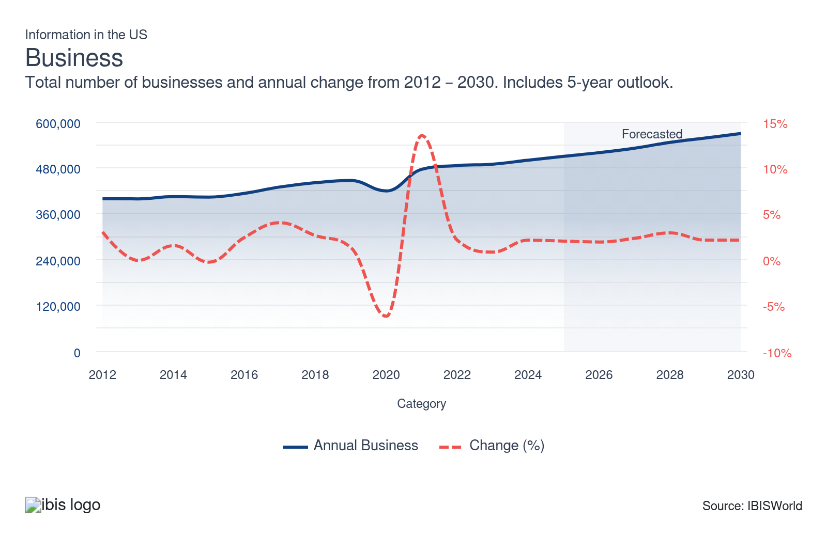
Profit: | ↑ 2020-25 Profit CAGR +2.0%
Total Profit  $313.7bn  ’20-’25 ↑ 2.0 % | Profit Margin  12.6%  ’20-’25 ↓ 0.3 pp | Profit per Business  $615.3k
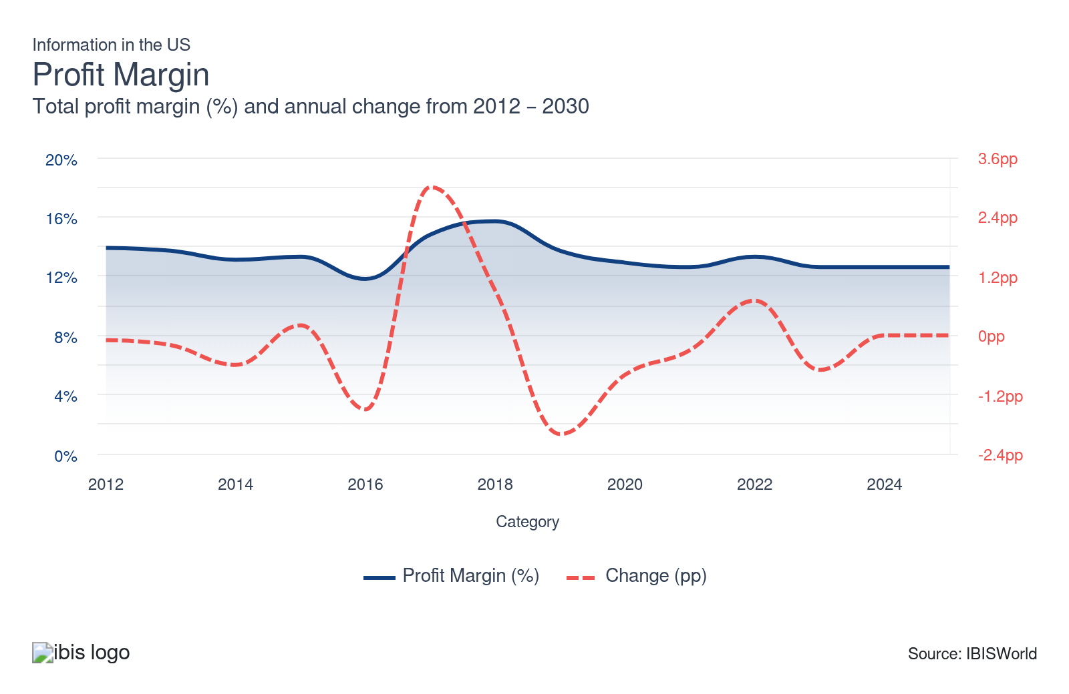
Current Performance
Current Performance

What's driving current industry performance?

Tech titans flourish amid digital boom
- According to the Pew Research Center, as of mid-2025, over 90% of US adults report using the internet and national broadband adoption stands at 77% of households, reflecting high but uneven digital infrastructure penetration. In Q1 2025, wireless broadband (including fixed wireless and 5G) connections increased by 7.6% year-over-year in the US, and satellite broadband subscriptions (notably Starlink) rose by 47.4%.
- The US data processing and hosting services industry is rapidly evolving amid increasing digitalization. Data centers have evolved into strategic assets that power services ranging from cloud computing to advanced analytics. Giants like AWS, Microsoft Azure and Google Cloud dominate the market, while smaller, specialized providers serve sectors such as healthcare, financial services and government with tailored data storage solutions.
- Major software companies, such as Microsoft, Apple and Google, have become some of the world's most influential entities, thanks to their ubiquitous presence in everyday devices. Over the past 20 years, these companies thrived, remaining resilient during economic downturns and growing even stronger during the pandemic.
- The wireless telecommunications industry has thrived. As households cut landlines, mobile internet demand surged, driving industry growth. This trend is set to continue as the shift to 5G technology allows businesses to redefine pricing and products for consumers. Revenue growth has been boosted by increased mobile internet usage. Overall, significant gains in internet adjacent industries has offset disruptions and slumps in more traditional subsectors.

Macroeconomic factors drive expansion within the Information sector
- The sector benefits from an expanding number of businesses and households, particularly in the higher-income quintile. The formation of a new household unit often goes hand in hand with subscriptions to telecommunications services, including voice, video and internet services, which are the largest subsectors of the information industry. Business formation has a positive impact on the sector, as businesses also require subscription-based communication services, software and data processing services.
- Shifts in consumer spending due to economic conditions directly impact demand for products and services, ranging from publishing to internet and phone services, leading companies to adapt quickly to changing market dynamics. Mounting consumer spending has benefited the information sector, as households represent a significant downstream market for industry businesses. With more disposable income, consumers are subscribing to streaming services, digital news and other online content.
- Advertising expenditure has also been a boon for the sector, as most subsectors of information sell advertising placements, whether in print pages, online displays, or video commercials. The Interactive Advertising Bureau reports that US digital ad revenue reached $259 billion in 2024, with digital video alone accounting for approximately $64 billion and representing just over half of all video ad spending.
- US government policies have also supported the growth of the information sector. For example, the FCC's moves to deregulate parts of the telecommunications industry and its spectrum auctions for 5G have catalyzed advancements in connectivity. Furthermore, tax breaks and incentives for research and development have encouraged companies to innovate and expand their operations.
- In 2024, the FCC voted to reclassify broadband as a Title II telecommunications service and reinstate net neutrality rules, signaling tighter oversight of blocking, throttling and paid prioritization. However, this move was halted in 2025 when the Sixth Circuit stayed the order, creating uncertainty for ISPs’ pricing and investment plans.

Shifting consumer sentiment dictates the direction of the sector
- Consumption of media content has surged alongside a rise in time spent on electronic devices, encouraging advertisers to catch up by purchasing placements in emerging channels. Pew reports that 95% of US adults use the internet and 90% own a smartphone; 78% subscribe to home broadband, cementing digital as the default gateway for news and entertainment.
- Most expansion has been concentrated in online publishing and data processing, albeit at the expense of more traditional information subsectors. For example, new digital channels have been detracting from print advertising expenditures through the end of 2024. Pew data points to about 53% of adults now get news at least sometimes from social media, confirming a structural shift away from print and linear broadcast outlets.
- The emergence of online streaming services has made consumers less reliant on traditional communication services, such as wired voice, broadband internet and cable TV, thereby reducing demand for telecommunications. Deloitte finds 82% of US consumers pay for at least one streaming video service, while nearly a quarter subscribe to four or more, signaling a deep attachment to digital platforms.
- Demand for exclusive and original content has soared, compelling streaming services to invest heavily in producing their own shows and movies. Netflix, for example, spent over $17 billion on original content in 2021. This has intensified competition and set new benchmarks for content quality, pushing traditional broadcasters to elevate their content offerings to keep pace.

Mergers and acquisitions are popular among the largest Information sector companies
- Companies strive to diversify their business and become more technology-neutral through mergers and acquisitions. AT&T Inc. acquired DirecTV in 2015 and Time Warner in 2018, combining the largest pay-TV provider in the United States with the leader in TV production. In 2024, T-Mobile agreed to acquire U.S. Cellular's wireless operations and select spectrum assets for $4.4 billion, following its merger with Sprint in 2020.
- In 2023, Microsoft finalized its $68.7 billion acquisition of Activision Blizzard, significantly strengthening its position in the gaming industry by expanding its gaming portfolio. Similarly, Amazon's 2022 acquisition of MGM Studios for $8.45 billion aimed to enrich its content library with MGM's vast collection of films and TV series. AT&T has leveraged the extensive media libraries of its recently acquired subsidiaries to launch Max, a streaming service that features WarnerMedia and Discovery's film and TV properties.
- To stay competitive, many traditional media companies either launch their own streaming platforms or partner with existing ones. NBCUniversal’s Peacock is an example of broadcast networks entering the streaming arena. In the same vein, mergers and acquisitions, like Disney's acquisition of 21st Century Fox, have been strategic moves to bolster content libraries and expand streaming portfolios. Skydance Media’s roughly $8 billion acquisition of Paramount Global (completed in 2025) marks the latest consolidation wave in film, TV and streaming, as it combines libraries and franchises to gain leverage in licensing and direct-to-consumer platforms.
- Technology giants like Microsoft and Alphabet have pursued acquisitions to enhance their digital and cloud services. Microsoft's acquisition of Nuance Communications, a leader in AI and speech recognition technology, underscores its strategic focus on healthcare cloud offerings. Alphabet's purchase of Fitbit expanded its reach into wearable technology and health data, underscoring its interest in broadening its consumer hardware and health market assets. These strategic moves reflect an overarching trend of acquiring emerging technologies and capabilities to maintain competitive advantage in an ever-evolving digital landscape.
- In early 2025, Alphabet’s Google announced a $32 billion all-cash deal to acquire cloud security firm Wiz, its largest acquisition ever, aimed at bolstering Google Cloud’s $48 billion business with advanced multi-cloud security tools. Cisco completed its $28 billion acquisition of data analytics company Splunk in 2024, betting on security and observability as core growth engines across data-heavy information services.

Cloud solutions and AI revolutionize media and publishing industries
- Over the past five years, the information sector has undergone a significant shift toward cloud-based solutions. Companies like Microsoft Azure, Amazon Web Services (AWS) and Google Cloud have become pivotal in providing scalable and flexible IT infrastructures, enabling businesses to handle massive amounts of data more efficiently. This has been particularly impactful for sectors such as publishing and media, where rapid adaptability is crucial.
- The adoption of artificial intelligence and big data analytics has revolutionized the way information is processed and utilized. AI technologies are being used for predictive analytics in media to forecast trends and optimize content delivery. For instance, media companies use AI to analyze user data and deliver personalized content, thereby enhancing user engagement and retention.
- Digital transformation has enabled companies to automate routine tasks, streamline operations and reduce manpower and operational costs. For example, publishing companies are using digital tools to automate editing and fact-checking processes, reducing time-to-market for new publications.
- Advanced data analytics have allowed companies to uncover new revenue opportunities by offering tailored services and targeted advertising. For instance, telecommunications companies are using customer data to develop new subscription models and personalized bundles, significantly increasing average revenue per user (ARPU).

What influences industry volatility?

The Information sector doesn't face significant revenue fluctuations
- The Information sector broadly encompasses creating and delivering media content, which is relatively steady in consumption. The growing popularity of online media has shifted consumption habits and the type of media and content produced by this industry.
- New technology can alter the distribution of revenue among the various information subsectors and many industries within the Information sector exhibit higher volatility. For example, the shift to digital has negatively impacted industries such as publishing, which rely on print products for revenue generation.
- Producer price indexes, which measure the amount businesses receive for their services, indicate a stable pricing environment, with September 2025 at 118.4, nearly unchanged from the previous quarter, suggesting steady demand despite competitive and technological shifts in underlying business models.

Digital disruption shakes up the Information sector
- The Information sector includes discretionary industries, such as movie theaters and cable providers, which thrive with higher disposable incomes. COVID-19 reduced household demand and corporate profit. However, telecommunications subsectors like VoIP experienced a surge due to increased demand for videoconferencing, as social distancing measures limited in-person interactions.
- Innovations in artificial intelligence, blockchain and machine learning continually change how information is processed and delivered. Companies must invest heavily in new technologies to stay competitive, which drives up costs and potentially leads to fluctuating revenue as they catch up.
- Traditional media outlets are now competing with digital platforms, including streaming services, podcasts and social media. This shift has fragmented audiences and advertising revenue, making income streams less predictable and stable.
- Consumers quickly adopt new technologies and trends, forcing companies to pivot rapidly to meet new demands. For instance, the plummet in cable subscriptions favoring streaming services has forced traditional broadcasters to find new revenue models.

Market consolidation creates waves
- Merger and acquisition activities create revenue turbulence as companies strive to achieve economies of scale and expand market reach. For instance, Salesforce's acquisition of Slack in 2021 aimed to bolster its offering of collaborative tools. While the merger promised synergies and potential revenue growth, integration challenges and initial acquisition costs can disrupt financial stability in the short term.
- Such activities can also trigger competitive responses that influence revenue. For example, the 2019 merger of Disney and 21st Century Fox intensified competition in the streaming market, prompting other companies like Netflix to strengthen content spending and strategy shifts, causing fluctuations in revenue as the industry adjusted to the new landscape.
- Consolidation often leads to market restructuring, which in turn impacts revenue dynamics. When Verizon acquired Yahoo and AOL, it aimed to create a digital ad powerhouse. However, challenges in integrating diverse assets and meeting ambitious revenue targets led to inconsistent earnings as the firms adjusted to new operational realities.
- Consolidation often attracts attention from regulators concerned with antitrust issues. Lengthy and costly legal battles, as well as forced divestitures, can cause temporary revenue dips and dampen investor confidence. Regulatory scrutiny of large-scale mergers can delay or alter transactions, creating uncertainty in revenue projections and potentially impacting financial outcomes. The legal challenges faced by AT&T’s acquisition of Time Warner illustrate how antitrust concerns can impact not only the companies directly involved but also wider market participants, affecting strategic plans and resulting in revenue unpredictability.

Regulatory shifts and privacy concerns cause economic uncertainty
- Data privacy regulations, such as the GDPR in Europe and CCPA in California, require ongoing adjustments to how companies manage consumer data. Adapting to these regulations involves significant compliance costs, non-compliance risks and hefty fines, creating variances in financial stability.
- New content moderation requirements and antitrust actions put pressure on digital platforms, potentially limiting their operations or forcing restructuring efforts. These legal challenges can interrupt established revenue streams or create an uncertain business environment, affecting overall financial performance.
- Escalating privacy concerns among consumers compel companies to enhance transparency and security measures. While meeting these expectations may engender customer loyalty in the long run, the immediate investment in increasing data security can result in short-term revenue fluctuations as financial resources are reallocated.
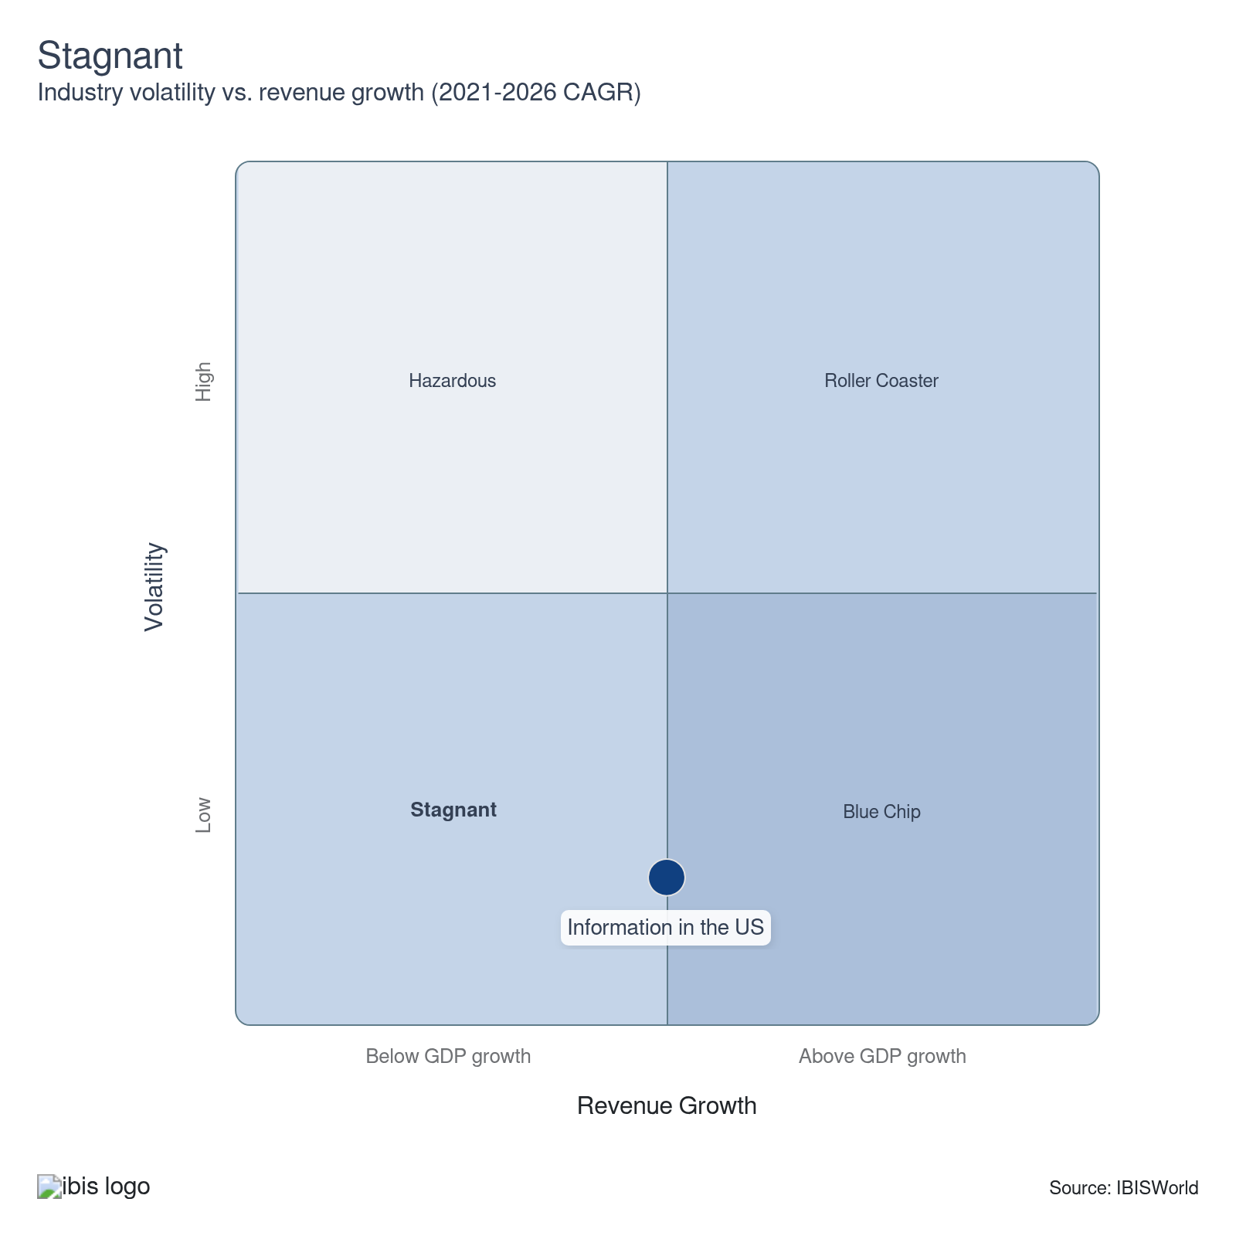

How do successful businesses overcome volatility?
Ability to quickly adopt new technology
Advancing technology drives productivity and efficiency gains. Enterprises must keep up with the latest trends to stay competitive. Staying informed ensures they maintain an edge in the industry, adapting to changing landscapes and capitalizing on new opportunities.
Close monitoring of competition
Information sector companies must closely monitor competition to stay competitive. Keeping up with the latest trends and technologies is crucial in this industry. Staying updated ensures they remain viable and can effectively compete in the market.
Effective cost controls
Information sector companies must effectively manage costs and budgets to meet clients' specifications and contractual arrangements and ensure industry profitability. This balance is crucial for maintaining operational efficiency and delivering consistent client value.
Secure a highly skilled workforce
A skilled workforce is necessary for various technical procedures across industries. Fields like publishing depend on the quality of employee work. This requirement underscores the importance of investing in training and development for staff.
Outlook | ↑ 2025-30 Revenue CAGR +2.4%

What's driving the industry outlook?

Tech evolution sparks surge in internet demand, cloud services, and digital media
- As society increasingly relies on digital networks, demand for internet services is set to soar. Fiber optic technology will enhance connection speeds, addressing the increased demand for reliable broadband following the pandemic. While 5G mobile services may challenge traditional ISPs, the industry will thrive as more individuals shift significant aspects of their lives online.
- The US data processing and hosting services industry is set for steady growth amid growing cloud-storage needs. Continuous innovation will drive this progress, ensuring that data centers continue to be pivotal in shaping the digital landscape moving forward. Compliance with evolving data sovereignty and privacy regulations will be crucial for maintaining competitive edges in local markets.
- New OS technology and productivity software are migrating to the cloud, enabling seamless integration across desktops, laptops, phones and servers. Subscriptions for productivity tools and digital video software will continue to add value. AI promises to cut wage costs and boost software usability, ensuring sustained investment in computing hardware.
- Traditional publishers and cable providers will confront the shift to digital platforms, e-books and subscription models. Cable companies will face subscriber losses as consumers prefer streaming services. Alliances with digital platforms and tech companies, along with investments in original, high-quality content, will be crucial for both sectors to remain competitive and effectively engage their audiences.
- Deloitte’s 2025 Digital Media Trends study reveals that social video platforms are now capturing a growing share of the six-plus hours Americans spend daily with media, directly competing with studios and broadcasters. These platforms also account for over half of US digital ad spending, forcing traditional information-sector players to rethink their content formats, partnerships and monetization models.

Rising private investments and consumer spending drive industry forward amid economic recovery
- Growth in both overall private investment and, more specifically, investment in computers and software will heighten industry participation as competition intensifies, with enterprises vying to tap into renewed business market demand.
- Economic uncertainty will be alleviated as interest rates regress and crucial up- and downstream markets are freed from supply chain issues. As the industry transitions from print media to embracing the digital frontier, investment activity will be imperative to facilitating a smooth evolution.
- Growth in consumer spending and disposable income will enable households to purchase industry products more freely. A potent incline in the number of households earning more than $100,000 will also bolster the household market and specifically a subset of that market that procures print publishing products, which are on the decline. Economic upswings will see increased spending on premium content and bundled services.
- Businesses in the information sector will need to remain nimble, using advanced analytics to track consumer behavior and market trends. Companies such as Disney, AT&T and Verizon may need to continuously innovate their content offerings and pricing models to align with evolving consumer preferences and economic realities. Economic growth will lead to increased advertising spending by businesses seeking to capture consumer interest.

Media forces pivot to OTT and 5G as traditional cable and print ads decline
- The number of cable TV subscriptions and print advertising expenditure will drop through the end of 2030, pushing down demand for traditional media. More media companies will launch their over-the-top services to capture additional revenue from creative properties, such as the recently launched Max service from WarnerMedia.
- As 5G (fifth-generation) mobile internet service is rolled out further nationwide, the popularity and usage of cellular internet will swell at the expense of wired broadband alternatives. The deployment of 5G networks significantly increases data transfer speeds, reduces latency and enables high-quality streaming and other data-intensive activities. Media companies are capitalizing on 5G for real-time event coverage and live streaming, offering more interactive and immersive user encounters.
- Through providers such as SpaceX, Satellite internet may also become a more popular alternative to more traditional internet access sources moving forward. Industry enterprises that stay ahead of the curve with the latest technological advancements in AI, network capacity and processing, as well as cloud technology, will gain a competitive edge.
- In response to sophisticated cyber-attacks, the information sector must invest in advanced cybersecurity measures to protect sensitive data and intellectual property. Stricter data protection laws, such as the GDPR in Europe and the CCPA in California, are prompting firms to adopt more comprehensive cybersecurity frameworks, ensuring they meet regulatory requirements and avoid hefty fines.

Streaming giants intensify rivalry with major acquisitions and diverse revenue models
- As Netflix, Disney+, Amazon Prime and emerging platforms compete, the quality and diversity of available content are reaching unprecedented levels, benefiting consumers. There's a significant investment in producing original content, with exclusive series, films and documentaries becoming key differentiators in the battle for viewer engagement and subscriber retention.
- Deloitte reports that 54% of US streaming subscribers already use at least one ad-supported service, an 8 percentage point increase in a year, as price fatigue prompts viewers to opt for cheaper, ad-supported options and cross-media bundles. Exploring various revenue streams, streaming services are introducing ad-supported tiers, premium subscriptions and bundled services to attract different audience segments and maximize profitability.
- Acquisition deals will often revolve around securing high-demand content. WarnerMedia’s acquisition of HBO allowed it to control critically acclaimed content. Expect more such deals aimed at obtaining exclusive IP rights. M&A deals will also aim at bringing premier creative talent under one roof. For example, Apple TV+ or Amazon Studios have acquired smaller production houses to secure top directors, writers and actors for original content.
- Major companies, such as Disney, WarnerMedia, and ViacomCBS, are expected to continue acquiring smaller streaming platforms and content creators. Consolidation enables firms to achieve economies of scale and a greater market share, thereby reducing competition and increasing their negotiating power with advertisers and content producers. This trend is likely to extend to smaller regional players being absorbed by national giants.

New technology adoption comes with unforeseen costs
- Government funding and initiatives will help close the gap in internet access across geographic regions and sociodemographic groups, which will continue to expand the consumer base for internet services.
- Demand for digital content and services, such as internet services, cloud computing and software, is poised to increase further. Conversely, demand for traditional media, such as print newspapers and radio programming, will continue to decline. Related information industries, such as newspaper publishers and radio broadcasting stations, are slated to suffer job losses.
- Generative and predictive AI will be embedded across content creation, recommendation and ad targeting, raising both productivity and R&D costs. Brookings notes that information-sector case studies already show AI lifting output while forcing firms to retool workflows and skills.​ McKinsey flags AI, agentic AI and application-specific chips as top tech trends through 2030, which will directly affect NAICS 51 efficiency and cost structures.
- The incorporation of AI into industry practices has created both opportunities and challenges for the industry, and enterprises will continue to navigate the benefits and drawbacks of integrating AI into their workflows. For example, recent writers' and actors' strikes have targeted AI as a displacing force, prompting Information sector enterprises to codify a stance on AI integration. In fact, AI-written content has already begun to permeate the publishing industry.
- AI-powered tools and subsequent models are revolutionizing the way content is generated, enabling the creation of news articles, blog posts, and even multimedia content with minimal human intervention. Companies are increasingly adopting machine learning algorithms to analyze large datasets, enabling more precise audience targeting, trend prediction and personalized marketing strategies. AI chatbots and virtual assistants are becoming increasingly sophisticated, handling customer inquiries, troubleshooting issues and even performing complex tasks, thereby effectively streamlining operations and enhancing user satisfaction.

Information sector regulation is poised to intensify
- Antitrust actions targeting major tech firms are gathering momentum as lawmakers strive to rein in monopolistic behavior in digital markets. Proposed measures seek to prevent anti-competitive practices by dominant players, fostering a level playing field for smaller entities in the information industry. These efforts are pivotal in ensuring a fair and competitive digital economy.
- As AI becomes integral to the information sector, new guidelines emphasize ethical application and transparency. Regulators are developing policies to govern the use of AI, ensuring it aligns with societal values. These efforts focus on mitigating biases and fostering accountability, engaging stakeholders to develop balanced frameworks that guide the responsible deployment of AI technologies.
- The Sixth Circuit’s 2025 decision striking down the FCC’s net neutrality order undercuts expansive broadband rulemaking and signals closer judicial scrutiny of major tech regulations, creating a less predictable environment for telecom and streaming investments.
- At the same time, the FTC–FCC memorandum of understanding on broadband and consumer protection emphasizes the need for more coordinated enforcement of billing, privacy and deceptive practices in information services.
Life Cycle | Mature

Why is the industry mature?

Contribution to GDP
The information sector makes a significant contribution to GDP, accounting for a substantial percentage of the overall economic output. BEA data show digital-economy activities (including many NAICS 51 services) expanded their share of nominal GDP from 7.8% in 2005 to about 10.3% in 2021, underscoring how internet connectivity and cloud-based services have more than offset the long slide in print.

Market Saturation
Streaming and connectivity have pushed core markets to the brink of their limits. By late 2023, approximately 95% of US homes, or around 123 million, had at least one streaming video-on-demand subscription. According to Nielsen, streaming now accounts for roughly 45% of total TV usage, surpassing the combined usage of cable and broadcast, while just a handful of platforms dominate viewing time. In wireless, AT&T, Verizon and T-Mobile control more than four-fifths of US mobile subscribers, underscoring how scale in networks and content catalogs concentrates power, even as consumers appear to enjoy an abundance of choice.

Innovation
Most expansion is concentrated in online publishing and data processing at the expense of more traditional information subsectors. For example, the emergence of new digital channels has led to a reduction in print advertising expenditures. Major companies continually introduce groundbreaking technologies and services, including AI-driven analytics, 5G networks and advanced cybersecurity solutions.

Consolidation
Megamergers have stitched together content libraries, distribution pipes and direct-to-consumer platforms into sprawling conglomerates. Disney’s acquisition of 21st Century Fox granted Disney control over a vast portfolio of film and TV assets, thereby strengthening its position in streaming and global licensing. AT&T’s $85 billion acquisition of Time Warner was a landmark vertical deal, pairing a telecom carrier with HBO and Warner Bros. These deals helped reduce the number of major media groups to a handful of giants, concentrating bargaining power over talent, advertisers and distribution partners and triggering a wave of follow-on consolidation across studios, cable networks and digital platforms.

Technology & Systems
New distribution technologies have upended who captures value without fundamentally changing what’s being sold. Streaming revenue is now set to overtake pay-TV subscription revenue, even though much of the programming, sports, scripted drama and news looks familiar to viewers. Over-the-top services and app-based aggregators have drawn audiences away from traditional cable bundles. Yet, the basic product, video and audio programming, remains recognizable. What has changed is the transport layer and data stack behind it. Recommendation engines, targeted ads and cross-platform subscriptions are shifting market power from last-mile distributors toward global platforms and cloud-based intermediaries.

4. Products and Markets
https://my.ibisworld.com/us/en/industry/51/products-and-markets
Largest Market  $858.9bn  Telecommunications | Product Innovation  High

Key Takeaways
- Telecommunications is struggling amidst changing consumer preferences. Younger households are ditching large cable packages and wired telephony, pushing the industry to adapt more to mobile and 5G technologies.
- Households are the largest single market in the information sector since most product and service offerings are geared toward consumers. The subsector most reliant on households is telecommunications, which is the final, consumer-facing step of many media distribution chains.
- The pandemic has supercharged growth in data processing and online publishing. With the skyrocketing demand for cloud-based products and digital advertising, these sectors have become key revenue drivers for the information sector.
- Print media revenues are being cannibalized by digital formats. As consumers and advertisers flock to precise and cost-effective online channels, traditional print publications can't keep up despite their digital editions.

Products and Services
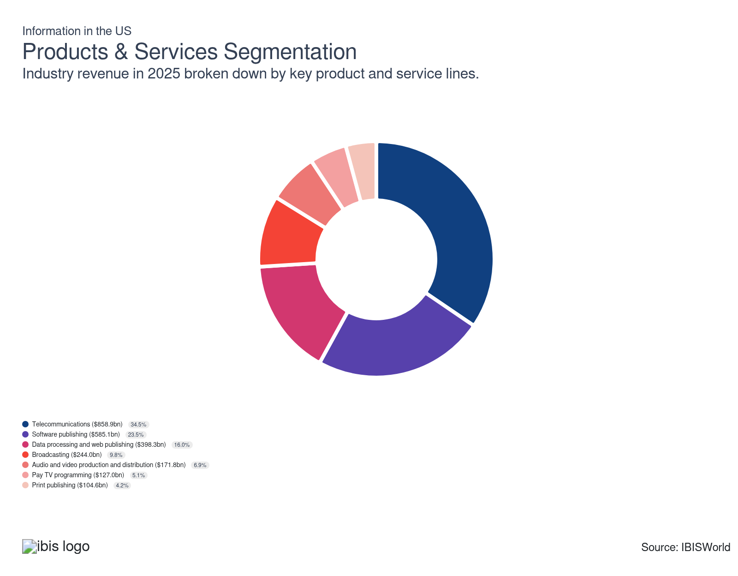

How are the industry’s products and services performing?

Telecommunications is the backbone of the information sector
- Telecommunications generates significant revenue by providing essential services such as mobile and landline telephony, internet connectivity and data hosting. Revenue streams also include subscription plans, usage fees and value-added services such as voicemail and messaging. Telecommunications remains the revenue engine of the information sector, accounting for more than $336 billion in US revenue in 2024 and employing nearly 1.8 million workers, over half of the sector’s total workforce.
- This segment includes voice, video and internet providers, whether they distribute over wired or wireless infrastructure. Although telecommunications accounts for the largest share of industry revenue among all product segments, it is in a slump due to younger households tending to pare down their service offerings, eschewing large cable packages and wired telephony. More than 38% of US adults now rely solely on wireless connectivity, eschewing landlines and traditional cable, legacy revenue streams face unprecedented pressure.
- Telecommunications has wavered, in part, due to the expansion of over-the-top media options. Cord-cutting increased by 7% in 2024 alone, with cable packages declining to under 55 million U.S. households, down from 92 million in 2010. However, the ongoing rollout of 5G (fifth-generation) wireless internet service will boost the usage of cellular data services at the expense of wired broadband internet.
- Telecommunications providers are the last step in the video content supply chain, and as media producers have bypassed them to reach consumers, telecommunications have endured revenue dips.

Data processing and online publishing explode in growth
- This segment includes cloud-based data storage, website hosting, search engines and content publishers that primarily operate online. The pandemic accelerated demand for cloud-based products, particularly for video streaming. The increasing importance of big data, e-commerce and digital advertising has further boosted this product segment.
- Demand for online publishing has surged in recent years because of technological advances, including cloud-based computing, which has expanded the data processing subsector. At the outset of the period, streaming video and new online advertising networks were nascent technologies. Cloud infrastructure spending is surging, led by Amazon Web Services, Microsoft Azure and Google Cloud, as businesses invest heavily in managed IT and video streaming to support hybrid work and e-commerce.
- Cloud-based storage companies also generate revenue via web hosting and managed IT services. E-commerce platforms, online advertisements and content subscriptions offer steady income streams. The BLS reports, in 2024, cloud and hosting services generated over $170 billion in revenue in the US, a 44% climb from 2020. More than 80% of US businesses now use some form of cloud computing.
- According to the BLS, digital ad revenue in online publishing surpassed $125 billion, reflecting advertisers' shift to measurable digital campaigns.

Software publishing encompasses a diverse product range
- Operating systems and productivity software comprise the largest segment in this subsector, followed by business analytics and enterprise software, database, storage and backup software, security software, video game software and design, editing and rendering software. Software publishing involves creating and distributing software products for various purposes, including applications and operating systems. This segment contributes to the Information sector revenue through direct sales, subscriptions and licensing agreements.
- This segment has primarily moved in line with the overall Information sector because of its diverse range of products and the vast array of businesses and consumers that require it. Software publishing has been propelled by the surge in demand for cloud services, SaaS solutions and remote work tools.
- Based on data from the BLS, software publishers in the US reported sectoral output of over $497 billion in 2023, up from $456 billion in 2022, demonstrating intensive growth that outpaces other content-focused segments. Data processing and hosting, including cloud services, have experienced a surge, with IT services spending under related NAICS codes increasing 65% from 2017 to 2022, while sales of physical computer equipment and storage declined by over 50% during the same period. This signals a shift in industry-wide business models from hardware-centric to cloud-based and managed service solutions.
- Subscriptions and licensing have displaced physical sales and enterprise platforms like Salesforce and Snowflake have set the pace for growth, capitalizing on the digital transformation that swept every industry.

Audio and video production and distribution has dipped in demand
- This segment of the sector encompasses film, TV, and music producers, as well as film distributors and record labels. Demand for an abundance of content has surged as online publishing and streaming have led to an influx of new competitors in this product segment. Audio and video production revenue is driven by content licensing, streaming services and pay-per-view models. Advertising partnerships and syndication deals further enhance profitability.
- Strong demand for film and TV, buoyed by massive investments in original content by over-the-top services, has been offset by substantial dips in music production and distribution as access to new music from subscription streaming services is provided at a fraction of the cost of purchasing it.
- While video streaming investments reached a record $30 billion annually in originals in 2024, the deluge of content and price competition eroded profit margins for mid-sized producers.

Digital formats cannibalize traditional print media revenues
- This segment includes publishers that primarily produce print publications, as well as any revenue they generate from digital editions. Advertisers have curtailed their print advertising expenditures in favor of new online channels, which offer more precise targeting.
- Although most print publications offer an online edition and most book publishers release e-books, digital audiences are less valuable and publishers have not been able to offset dips in print advertising with new digital channels. In 2024, print accounted for less than 12% of total US publishing revenue. The remaining income comes from digital e-books, online subscriptions, and digital ad sales, however, digital’s lower margins and user churn limit publishers’ pricing power.
- While traditionally, most publishing revenues stemmed from direct sales, subscriptions and advertising space within publications, companies in this segment have adapted to digital formats such as eBooks and online articles, creating additional income opportunities.

Pay TV programming and broadcasting make up a small but loyal income source
- Pay TV includes any cable or premium subscription TV network and broadcasting encompasses radio and network TV. Historically, stable revenue was generated through monthly subscription fees and premium channel packages. Many companies in this segment now offer over-the-top online services to offset long-term declines in traditional TV consumption.
- Despite a drop in subscriber numbers, premium channels like HBO and live sports broadcasting maintain loyal audiences, which can fetch premium carriage fees and exclusive advertiser deals. The hybridization of linear television with digital streaming, exemplified by services like Hulu + Live TV and YouTube TV, blurs market lines but keeps broadcasters in the game, even as audiences scatter across various platforms.
- This segment has remained fairly stable through the end of 2025, despite a drop in cable subscription rates and live TV viewership. The telecommunications companies closest to the consumer have felt these negative trends more.
- Broadcasting includes the transmission of radio and television programs for public and private consumption. Advertising sales during commercial breaks represent a significant revenue source. Additional income originates from syndication rights, sponsorship deals and special event coverage. The enduring popularity of radio consumption and the hybridization of television with digital platforms for broader audience engagement have contributed to a stagnating broadcast segment.

What are innovations in industry products and services?

Artificial intelligence and machine learning integration
- AI and ML technologies enable companies to analyze vast datasets quickly and accurately. For instance, natural language processing (NLP) allows for sophisticated text analysis, while computer vision technology can efficiently classify and interpret images and videos.
- Artificial intelligence has become a cornerstone for growth, with the National Center for Science and Engineering Statistics reporting that 34.7% of information sector companies led by S&E degree holders have reported recent innovations tied to AI or advanced analytics.
- Platforms like Netflix and Spotify use AI algorithms to analyze user behavior and preferences, delivering personalized content recommendations. This not only improves user experience but also increases engagement and retention rates. Businesses leverage ML models to predict market trends, customer behaviors and potential risks. This foresight allows companies to make data-driven decisions, optimizing operations and strategic planning.
- Companies like Google and Microsoft have invested billions in cloud-based AI ecosystems, giving even small firms access to powerful analytics through cloud APIs.

Cloud computing and storage solutions
- Cloud platforms, such as AWS, Google Cloud, and Microsoft Azure, offer scalable computing power and storage solutions. Businesses can easily scale resources up or down based on demand, ensuring optimal performance without over-provisioning. According to the BLS, over 80% of US businesses now use at least one cloud-based solution.
- By adopting cloud solutions, companies can reduce their capital expenses on IT infrastructure. Pay-as-you-go models enable businesses to pay only for the resources they use, converting fixed costs into variable costs and enhancing financial flexibility. Multi-cloud and hybrid models have enabled businesses to drive innovation in SaaS, data analytics, and secure remote work environments.
- Cloud services offer disaster recovery solutions that eliminate the need for a secondary physical site. Data is automatically backed up and can be quickly restored, minimizing downtime and data loss in the event of a disaster. Cloud-native platforms enable rapid software development and deployment, shrinking time-to-market and making robust IT accessible to firms of all sizes.
- Giants like Amazon Web Services, Microsoft Azure and Google Cloud spearhead this innovation, generating over $170 billion in US cloud services revenue in 2024.

Streaming and digital media reshape content consumption
- Streaming platforms now leverage AI-driven, content-aware encoding, using neural networks to adjust bitrates and resolution in real-time, depending on the type of content and network speed. These technologies tailor video delivery not only to content, but also to the viewer’s device and connection, maximizing perceived quality and ensuring a smoother, more efficient experience in everything from mobile gaming to high-speed sports broadcasting.
- Edge computing is increasingly used for video encoding, as processing and caching streams closer to end-users enables platforms to reduce latencies. This is particularly vital for live events, esports, betting and interactive entertainment.
- Context-aware encoding and ultra-low latency streaming require integrating advanced codecs and edge AI into the infrastructure, which pushes streaming far beyond simple content delivery and enables truly real-time, device-optimized experiences at scale.

What products or services do successful businesses offer?
Establish brand names
Brand names can influence buyers' perceptions and help drive sales. Companies invest heavily in marketing their services to consumers, even as they rely on clients' downstream advertising expenditures. Building strong brand names fosters customer trust and loyalty, helping retain clientele even during volatile periods.
Align cost-effective delivery with client needs
Effective cost control aids in achieving price competitiveness and profitability. Automation cuts costs, while larger enterprises leverage their size to secure competitive supplier prices. Adapting quickly to changing demands reduces the risk of losing business during market shifts, keeping the operation steady and competitive.

Major Markets
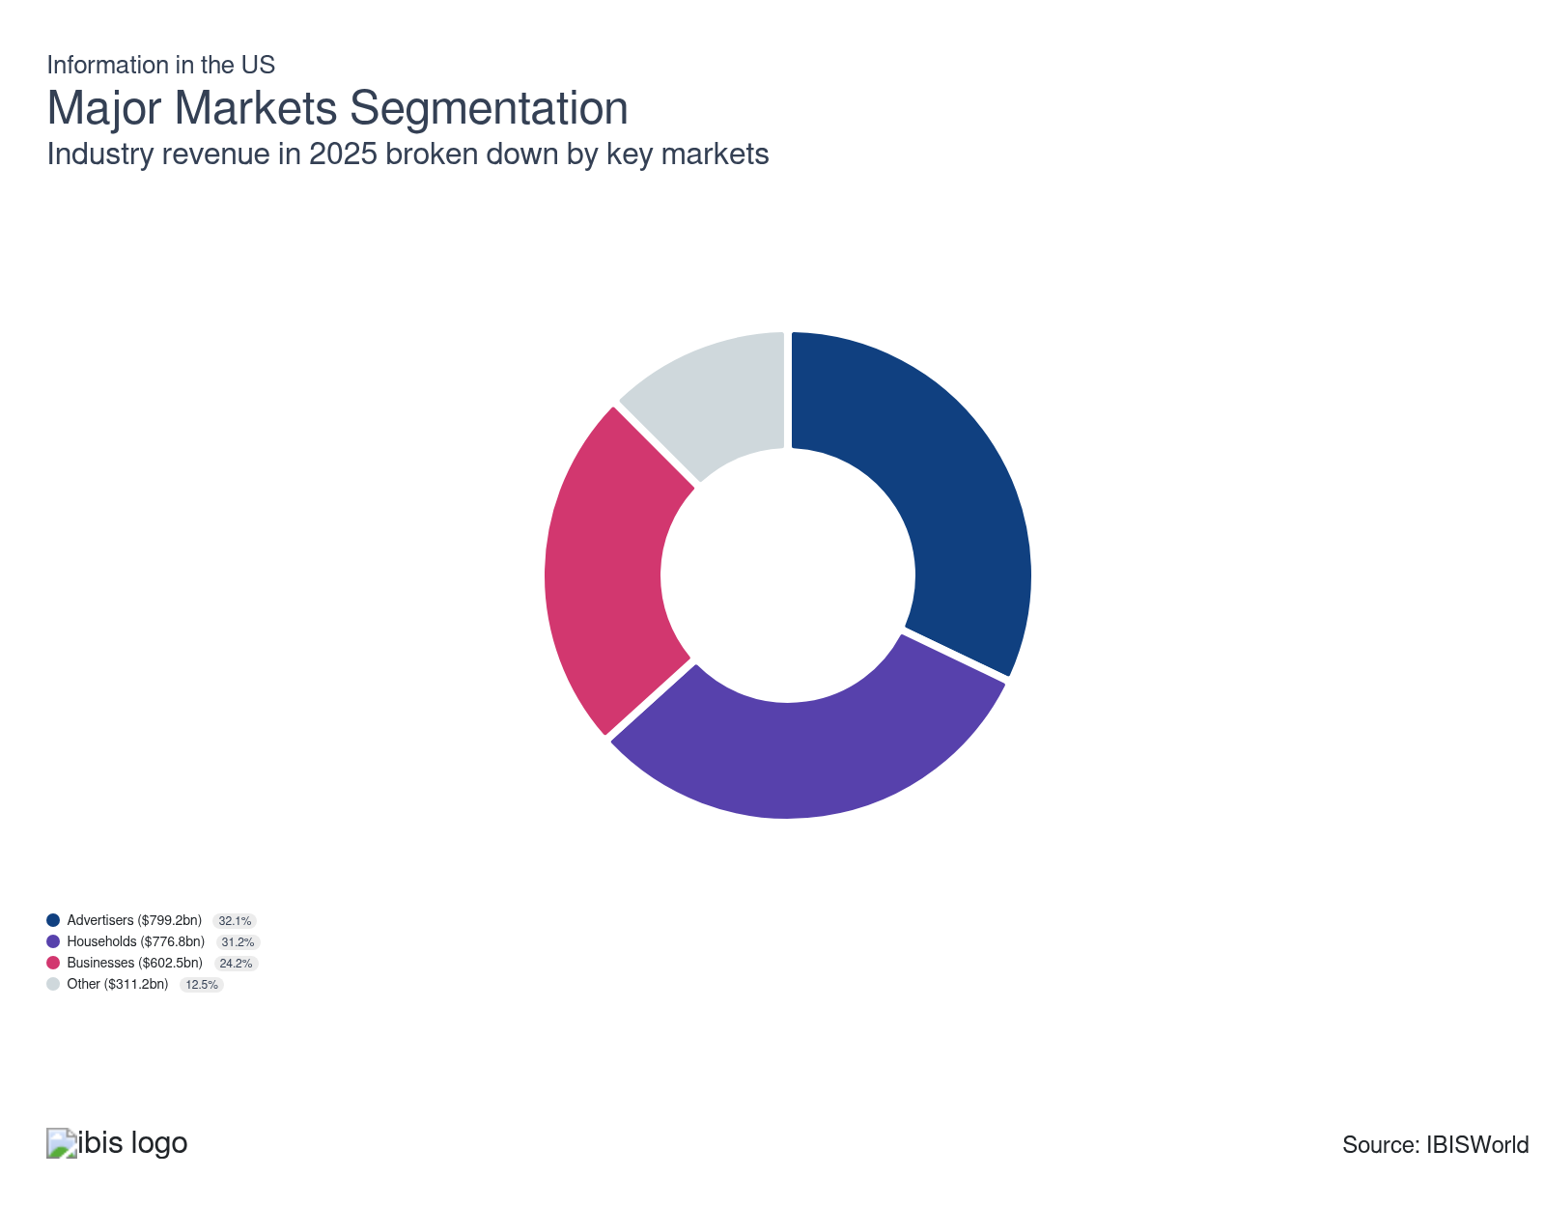

What’s influencing demand from the industry’s markets?

Households are a foundational customer of the Information sector
- Most of the Information sector's product and service offerings are geared toward consumers, but this market segment only includes revenue generated directly from households. The subsector most reliant on households is telecommunications, the final, consumer-facing step of many media distribution chains.
- Several steps are taken along the sector's distribution chain before the content reaches the consumer; for example, film studios produce content for household consumers, but most revenue is generated directly from movie theaters or other commercial entities that license the content.
- Households have become even more crucial to the information sector’s revenue mix as digitalization accelerates. As of 2025, over 90% of US households had broadband access and national annual revenues for consumer telecom services exceeded $240 billion, according to the BLS. Giants like AT&T and Verizon held nearly two-thirds of the residential market across mobile, broadband and bundled offerings.
- Demand from this market has surged due to the prevalence of streaming platforms and heightened digital content consumption. The prevalence of subscription models has made households a stable revenue source for information sector enterprises.
- The decline of traditional print is dramatic. The BLS reports newspaper industry revenues dropped below $20 billion in 2024, a 51% drop from a decade prior. Meanwhile, digital publisher numbers now outnumber print by more than 4 to 1, maintaining a lower concentration and greater competition for household dollars. Even so, flagship brands such as The New York Times have leveraged hybrid models, with digital subscriptions now comprising nearly 70% of total publishing revenue.

Businesses adapt to an increasingly digitzed world
- This segment encompasses businesses that purchase sector products and services for end use or redistribution and does not include advertisers. Businesses are primary end customers in some segments, including software publishing and data processing. In other subsectors, such as audio and video content production and distribution, businesses generate a significant amount of revenue because they rely on intermediaries, including theaters, over-the-top services and TV networks, to reach consumers.
- Businesses are driving robust growth in the B2B segments. According to the BLS, software publishing generated more than $497 billion in output in 2023, powered by strong corporate demand for enterprise resource planning, data analytics, cloud services and cybersecurity solutions.
- The share of cloud service revenue derived from business subscriptions now exceeds 61% in the US, underscoring the sector’s deep integration into digital transformation initiatives following the pandemic. Companies like Snowflake and Salesforce have quickly expanded their market footprint through scalable SaaS models that serve both SMEs and large enterprises.

Advertiser demand fluctuates in line with the economy
- Trends in advertising expenditure vary between subsectors. Print advertising, on the one hand, has declined as consumers have shifted away from print media and marketers have followed suit. Meanwhile, advertising has surged overall, with gains mainly accruing in online channels. Display ads, sponsored content and platform promotional partnerships attract substantial advertising dollars. Ad revenues support free or discounted access to information services for end-users, expanding the audience.
- Demand for digital advertising has grown exponentially as companies move their marketing budgets from traditional media to digital platforms, driven by the need for more targeted and measurable advertising strategies. Digital advertising revenue reached a record $211 billion in 2024, with tech platforms, such as Google and Meta, capturing more than 55% of total US ad spend through display ads, search, sponsored content and native integrations.
- The result is a feedback loop. More advertising dollars enable expanded free or subsidized consumer offerings, which broaden the audience and increase sector reach. Meanwhile, broadcast and print ad revenues remain under pressure, declining 7% year-over-year as more marketers chase the precision and analytics of digital spend.

The government is the most significant other customer for the industry
- Federal, state and local governments are a crucial customer segment for the information sector, purchasing a range of services, including secure telecommunications, broadcast services, cloud infrastructure, data analytics and digital archiving solutions. In fiscal year 2024, the federal government alone awarded $773.7 billion in contracts, with professional services, IT and digital infrastructure accounting for a significant portion of this expenditure.
- Agencies prioritize network security, resilient communications and modernization, driving demand for enterprise-grade platforms and specialized content distribution. For instance, NASA, the Department of Defense and the Census Bureau routinely contract major telecom providers and data services firms for large-scale digital projects and population management initiatives.
- Government customers procure services through Government-Wide Acquisition Contracts (GWACs) and Indefinite Delivery/Indefinite Quantity (IDIQ) vehicles, with $74.8 billion awarded in fiscal year 2024, enabling rapid deployment for national security, disaster response and infrastructure modernization. These steady contracts insulate the sector from broader economic volatility and often catalyze innovation, as suppliers invest in compliance, cybersecurity and reliability to meet strict public-sector standards.
- Government-funded research partnerships, such as those with the National Science Foundation or the Department of Energy, directly accelerate R&D and technological advancements in key subsectors, particularly cybersecurity, cloud computing, and digital communications.

International Trade

Some industries don't directly import or export goods. See reports at the manufacturing level for international trade data on relevant products.

5. Geographic Breakdown
https://my.ibisworld.com/us/en/industry/51/geographic-breakdown

Key Takeaways
- Establishments in the Information sector tend to follow the distribution of the US population. Telecommunications companies represent a large chunk of the Information sector, and they must maintain offices and retail locations across the country to serve household customers.
- Urban markets attract numerous competitors in the telecommunications subsector, whereas rural markets commonly only have one provider. Broadcasters and many print periodicals serve local markets and market a product that cannot be easily distributed across long distances.
- California and New York lead the Information sector. These states attract tech and media companies due to their skilled labor pools and established industries.
- States with favorable tax and regulatory environments are hot spots for tech firms. Low corporate taxes and streamlined regulations make places like Texas, Florida, and Utah very appealing.

Business Locations
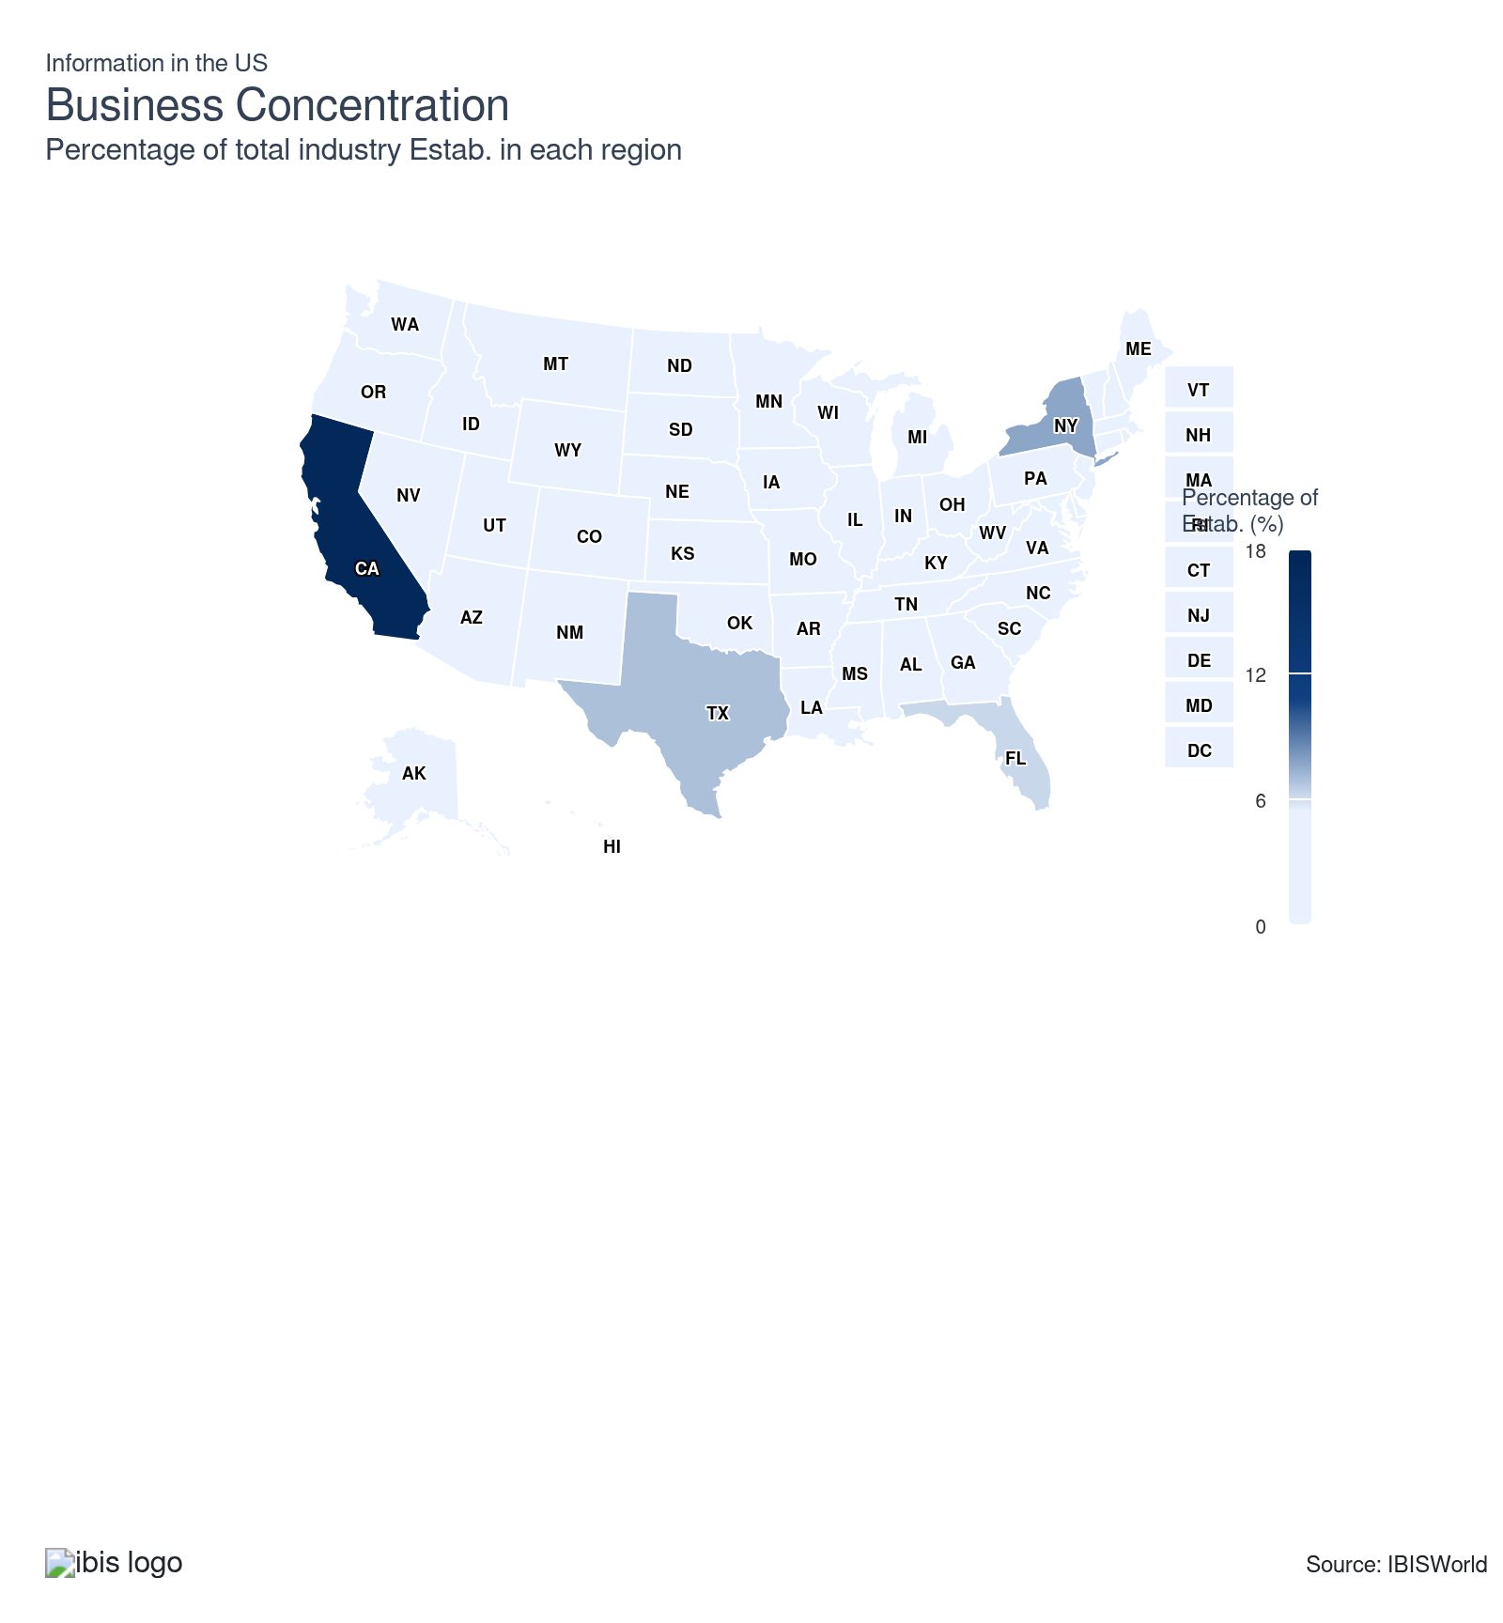
State | Estab.  Units | Estab.  % | Population  %
California | 27894 | 4.8 | 11.5
New York | 12352 | 2.1 | 5.8
Texas | 11165 | 1.9 | 9.3
Florida | 10058 | 1.7 | 7.0
Illinois | 5917 | 1.0 | 3.7
Pennsylvania | 5674 | 1.0 | 3.8
Georgia | 5167 | 0.9 | 3.3
Ohio | 4285 | 0.7 | 3.5
Michigan | 4207 | 0.7 | 3.0
North Carolina | 4114 | 0.7 | 3.3
Washington | 4186 | 0.7 | 2.3
Colorado | 3952 | 0.7 | 1.8
Virginia | 3964 | 0.7 | 2.6
Massachusetts | 3806 | 0.7 | 2.1
New Jersey | 3854 | 0.7 | 2.8
Tennessee | 2951 | 0.5 | 2.1
Arizona | 2662 | 0.5 | 2.2
Minnesota | 2717 | 0.5 | 1.7
Missouri | 2732 | 0.5 | 1.8
Wisconsin | 2527 | 0.4 | 1.7
Indiana | 2483 | 0.4 | 2.0
Maryland | 2475 | 0.4 | 1.8
Oregon | 2412 | 0.4 | 1.2
Alabama | 1829 | 0.3 | 1.5
Utah | 1880 | 0.3 | 1.0
Connecticut | 1818 | 0.3 | 1.1
Kentucky | 1809 | 0.3 | 1.3
South Carolina | 1762 | 0.3 | 1.6
Iowa | 1610 | 0.3 | 1.0
Louisiana | 1558 | 0.3 | 1.3
Nevada | 1571 | 0.3 | 1.0
Kansas | 1424 | 0.2 | 0.9
Oklahoma | 1515 | 0.3 | 1.2
Arkansas | 1178 | 0.2 | 0.9
Mississippi | 1043 | 0.2 | 0.9
Nebraska | 956 | 0.2 | 0.6
District of Columbia | 853 | 0.1 | 0.2
Idaho | 873 | 0.1 | 0.6
Maine | 805 | 0.1 | 0.4
New Hampshire | 784 | 0.1 | 0.4
New Mexico | 850 | 0.1 | 0.6
Delaware | 718 | 0.1 | 0.3
Hawaii | 602 | 0.1 | 0.4
Montana | 695 | 0.1 | 0.3
West Virginia | 654 | 0.1 | 0.5
Alaska | 415 | 0.1 | 0.2
Rhode Island | 443 | 0.1 | 0.3
South Dakota | 449 | 0.1 | 0.3
Vermont | 491 | 0.1 | 0.2
Wyoming | 444 | 0.1 | 0.2
North Dakota | 347 | 0.1 | 0.2

Where are industry businesses located?

The west is a home for a majority of information sector enterprises
- Regionally, the sector is concentrated in coastal and metropolitan areas, particularly in the West, where more than 1.4 million are employed in information jobs, supporting the nation’s broader tech and media leadership, according to the latest US Census data.
- The West’s innovation hubs, including San Francisco, Seattle and Phoenix, benefit from an expansive ecosystem of established tech giants, high-growth startups and top-tier research universities. San Francisco and Seattle alone support hundreds of thousands of tech jobs. Aggressive public and private investment in digital infrastructure—from fiber to cloud data centers—enables information sector companies to scale rapidly and serve large, innovation-driven markets.
- The region attracts significant venture capital, with Ernst & Young reporting that the Bay Area accounted for nearly 70% of all US VC investment in Q1 2025, driving startup formation and rapid growth in information sector companies.
- Companies in the information sector often prefer states with comprehensive yet balanced data privacy regulations. For instance, California's CCPA (California Consumer Privacy Act) is stringent, but it offers clear guidelines that can enhance customer trust, making it an attractive option despite higher compliance costs.

The mid-atlantic is a magnet for publishing and network companies
- The Mid-Atlantic, led by Northern Virginia, boasts the nation’s densest fiber optic networks and more than 250 data centers, making it the largest data hub in the world and powering a cluster effect for telecom, cloud and data processing businesses.
- The proximity of the federal government, especially around Washington, D.C., nurtures contracting and compliance-focused tech firms. Defense and civilian agencies award over $10 billion in annual IT services contracts, fueling steady demand and stable job creation in the region.
- The region’s low commercial electricity rates and generous tax incentives, like Loudoun County’s 6% sales and use tax exemption on data center equipment, substantially lower operating costs for information sector businesses, driving further investment and expansion.
- A highly educated workforce and top universities in Maryland, Virginia and D.C. provide a steady pipeline of tech talent, reinforcing the Mid-Atlantic’s status as a prime location for high-growth, information-driven establishments.

Information sector establishments take advantage of locating in the Southeast
- The Southeast’s business-friendly climate, marked by lower taxes, right-to-work laws and competitive economic incentives, attracts information sector firms, with Florida and North Carolina ranking among the top states in economic momentum and new business formation.
- Major metropolitan areas, such as Atlanta and Orlando, have developed advanced infrastructure, including high-speed broadband and data centers, which enable companies to deploy and scale digital services efficiently. Orlando alone surpassed $200 billion in GDP and led in job growth among large metropolitan areas in 2024, driving local demand for media, telecom and IT services.
- The region’s rapid population growth fuels demand for broadband, streaming, and other digital communication services, supporting expansion in telecommunications and broadcasting. Large clusters of tech, creative and research talent in hubs like Atlanta’s “Silicon Peach” attract investment from the information sector.
- Active local government support, including grants, training programs, and technology partnerships, helps new and expanding companies overcome entry barriers and sustain growth, further boosting the sector’s establishment count in the Southeast.
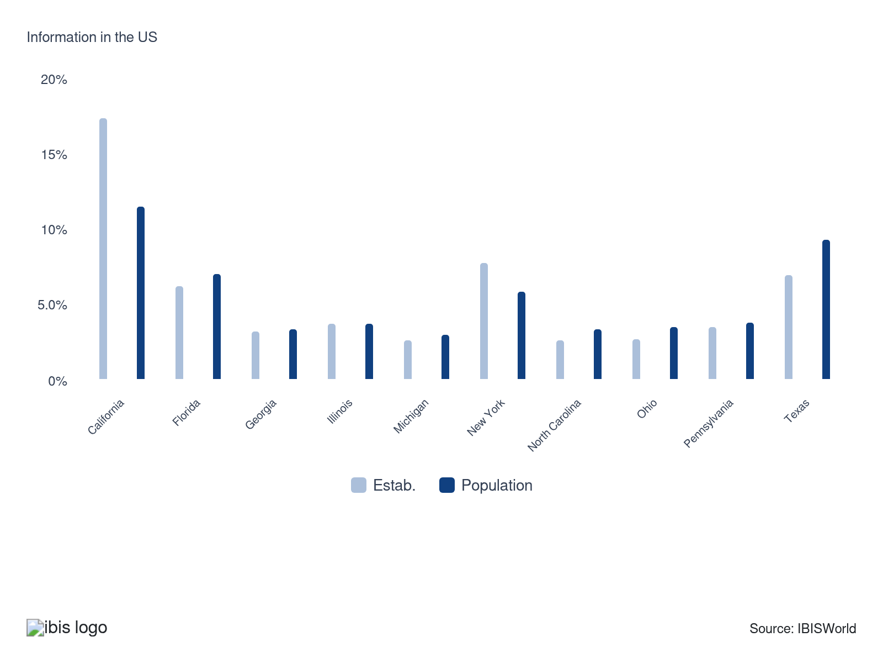

How do businesses use location to their advantage?
Control distribution arrangements
By controlling distribution arrangements, information sector operators can strategically select locations with optimal internet and data infrastructure. This enhances content delivery speed and reliability, directly influencing user experience and customer satisfaction.
Ensure skilled labor is available
Access to skilled labor allows information sector companies to establish operations in tech hubs or academic areas. This proximity to talent pools enables swift innovation and efficient problem-solving, driving competitiveness and growth.

6. Competitive Forces
https://my.ibisworld.com/us/en/industry/51/competitive-forces

Key Takeaways
- A major basis of competition for the Information sector is the mode and medium through which content is delivered. For example, online content publishers have competed by providing content much more quickly and at a lower cost than legacy media.
- Strong distribution networks can make or break a company. Companies that can efficiently get products to consumers quickly often capture larger market shares and create entry barriers for competitors.
- Tech giants don't completely stifle competition. Despite the dominance of big players like Google and AT&T, smaller firms can still thrive by finding niches and leveraging innovation to carve their own unique spaces in the market.
- Innovation keeps the industry dynamic and competitive. Rapid technological change means that even startups, often backed by venture capital, can disrupt established markets and challenge incumbents, ensuring the information sector remains vibrant and ever-evolving.

Concentration
Low
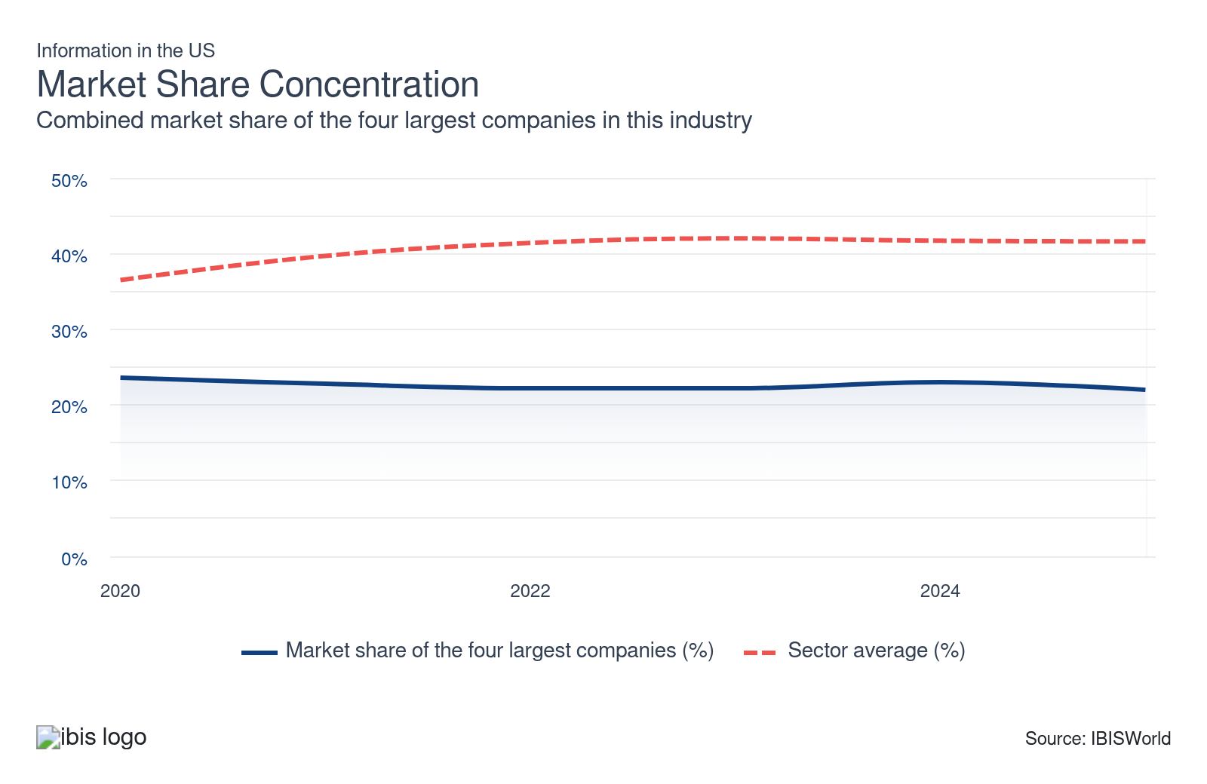

What impacts the industry’s market share concentration?

Companies with stronger distribution networks often control a bigger market share
- Companies with robust distribution networks, particularly those in the telecoms and digital platforms sectors, have leveraged their infrastructure scale to achieve dominant market shares. For example, Netflix leads the global streaming market with 269.6 million subscribers, followed by Amazon Prime Video at 220 million and Disney+ at 150.2 million.
- In the telecom industry, massive investments in fiber and wireless infrastructure by AT&T and Verizon anchor their regional dominance, while their supply-chain muscle enables them to efficiently reach and retain millions of subscribers. This scale helps ensure rapid product delivery and high customer satisfaction, and raises formidable barriers for new entrants that lack comparable channels or capital.
- The sheer cost and complexity of setting up these distribution networks, such as nationwide fiber optics or global content delivery, can deter newcomers. Yet, the existence of niche over-the-top providers (such as Sling TV) and globally scaled disruptors (like TikTok) demonstrates that success is still possible for new entrants with a differentiated offering or novel monetization strategy. Localized publishing, specialized SaaS and bespoke production studios also bypass mass distribution entirely, using online direct-to-consumer models to carve out sustainable market positions.

The dominance of big players does not dissuade new entrants
- Large incumbents undeniably wield strong influence, but their market share is far from monopolistic. Digital music, for instance, sees Spotify thrive alongside giants like Apple and Amazon, while the US media streaming market’s North American segment was split among several top players, none of which exceeded a 50% share by revenue in 2024. Such fragmentation is also evident in software and SaaS, where no single vendor dominates all enterprise needs and even global titans face strong competition from focused, high-growth startups.
- Beyond the overarching domains of search engines, social media and cloud services dominated by large firms, there are specialized segments, such as digital publishing and niche software development (including SaaS solutions). Companies in these sub-sectors can find lucrative opportunities without directly competing against the behemoths.

The level of concentration varies given the breadth of industries encompassed by this sector
- Vertical integration, especially between content producers and telecom service providers, intensifies concentration in capital-heavy subsectors. Major streaming and cable bundles, as well as mobile carriers acquiring media studios, reinforce entrenched market positions. By contrast, the fragmentation of digital publishing, with hundreds of thousands of online news, analysis and entertainment brands, keeps barriers lower and ensures that industry concentration remains comparatively light in this segment.
- The publishing industry has lower concentration levels because barriers to entry are relatively low. Print publications have consolidated at the national and local levels. Meanwhile, the high volume of digital publications keeps the online market fractured.

Technological innovation fuels competition in the sector
- The pace of technological change in the information sector means that new entrants can and often do, disrupt the status quo. Consider how TikTok emerged and captured a significant market share in the social media landscape, posing a threat to incumbents like Facebook and Instagram.
- The information sector is fertile ground for venture capital investment. This influx of funding enables startups to bring cutting-edge ideas to market, thereby fostering a competitive environment. For instance, companies like Snowflake have scaled rapidly in cloud data warehousing, largely thanks to significant venture capital backing. The presence of such startups ensures the sector remains dynamic and competitive.

How do successful businesses handle concentration?
Quickly adopt new technology
Staying on the cutting edge ensures that enterprises can offer the latest and most efficient solutions, outperforming competitors and meeting market demands swiftly. As the industry moves toward further embracing online mediums, technology integration becomes more emphasized.
Undertake ongoing research and development on existing and new products
Continuous innovation keeps companies ahead by improving existing offerings and creating new products, which attracts and retains customers in a competitive landscape.

Barriers to Entry
High | Steady

What challenges do potential industry entrants face?

Legal
- New entrants in the information sector contend with a complex legal landscape. According to the US Chamber of Commerce, in 2024, over half of small businesses identified licensing, certification and permit requirements as key obstacles to expansion, driving up legal bills and diverting funds from product development. Copyright disputes can swiftly escalate; for example, even modest content startups risk multi-million-dollar penalties if they infringe on protected works. Legal reviews, privacy audits and insurance products are now routine for all but the smallest players, creating a significant cost barrier.

Start-up costs
- Entrepreneurs must navigate varied and sometimes steep start-up costs. Licensing for online broadcasting or streaming can run tens of thousands of dollars annually, while a competitive cloud-based service may require upwards of $200,000 just for initial compute and network infrastructure. Most segment launches demand both advanced server setups and premium content or user experience investments. The US Small Business Administration considers these entry costs a dominant factor in industry structure, pointing to the broad gap between initial funding for small businesses (<$100,000) versus mid-sized to large ventures (well over $1 million).

Differentiation
- Entrants face daunting headwinds in trying to stand out in a market dominated by global incumbents like Google and AT&T. To avoid being overshadowed, newcomers must offer distinctly innovative experiences and invest heavily in branding and marketing. However, even breakthrough features are easy to replicate or emulate by giants who control massive user networks and have acquisition budgets in the billions. Success stories often hinge on finding a tight audience or leveraging new delivery channels that the big players have yet to dominate.

Capital Expenses
- The capital requirements for entering telecommunications or broadcasting are extraordinarily high. Data from NYU Stern shows America’s telecom providers invested nearly $90 billion in infrastructure upgrades in 2024 alone, nearly half devoted to expanding fiber and 5G capacity. Aspiring competitors must also secure federal spectrum licenses, negotiate costly distribution deals and continually upgrade R&D capabilities to keep pace with rapid technological advancements and evolving consumer expectations. Broadcasting stations in the US required capital expenditures averaging $1.31 billion in 2024, making the entry gap especially steep, except for the best-funded applicants. High fixed costs anchor the dominance of established enterprises while keeping the field tough for newcomers.

How can potential entrants overcome barriers to entry?
Close monitoring of competition
Keeping a close eye on competitors helps information sector companies identify new trends and technologies early, allowing them to adapt swiftly. This proactive approach also helps them discover market gaps or weaknesses in competitors' offerings, making entry smoother and more strategic.
Develop marketing expertise
Mastering marketing enables information sector companies to effectively communicate their unique value propositions to potential customers. This skill ensures they can build strong brand recognition and customer loyalty quickly, which is crucial for standing out in a crowded market.

Substitutes
Moderate | Steady

What are substitutes for industry services?

The Information sector has many substitutes internally
- Subsectors that include newspaper, magazine, periodical and book publishing are often substituted for TV, music or movies, which are also covered within the information sector. Online news outlets and streaming services are gradually replacing newspapers, television and radio. Social media platforms serve as a direct channel for information dissemination, reducing reliance on conventional broadcasting.
- Wired telecommunications carriers face competition from wireless counterparts and satellite telecommunications providers, competing to fulfill consumers' internet connectivity needs. As cloud services advance, data processing and computation become more efficient, driving adoption away from hardware-heavy approaches.
- Social media, video-first platforms and influencers have disrupted conventional publishing and broadcasting. In Deloitte’s 2025 survey, 56% of Gen Z and 43% of millennials said social media content is more relevant than classic TV or movies. Users spend 54% more time per day watching user-generated content than with scheduled programming.

External substitutes for the Information sector are limited
- The Information sector is a unique service-producing sector, indicating that the number of substitutes is extremely limited. The sector encompasses a wide range of products and services, including newspapers, radio, TV, the Internet and social media. Consumers have been using many of these products and services for nearly a century and are deeply integrated into their daily lives, making very few substitutes.
- Since smartphones became ubiquitous, distinct subsectors increasingly overlap. Phones combine news, music, social media, e-books, live streams and video chat into one device, fusing industry boundaries and making it nearly impossible for most consumers to depart from the digital ecosystem.
- The integration of information services into daily routines sustains high demand and reduces vulnerability to external replacement. Alternatives such as in-person events, postal mail, or analog radio reach only niche audiences, digital options remain the default, even for social, commercial and educational interactions.
- The sector’s breadth and entrenchment are reflected in time and spending statistics. Based on data from Deloitte, US adults spend an average of six hours per day interacting with digital media and entertainment, splitting their attention across streaming, gaming, podcasts, social feeds and news sites, none of which are truly substitutable by non-digital options.

How do successful businesses compete with substitutes?
Ability to quickly adopt new technology
Staying ahead with the latest tech ensures information sector companies can offer innovative solutions that competitors can't match, reducing the risk of customers switching to substitutes.
Close monitoring of competition
By keeping a keen eye on what competitors are doing, enterprises can preemptively address vulnerabilities and enhance their offerings, making substitutes less attractive to their audience.
Effective cost controls
Maintaining competitive pricing through efficient cost management makes it hard for substitute products to compete, as customers will gravitate toward the better-value option.
Secure a highly skilled workforce
A highly skilled team delivers superior quality and innovative services, making it difficult for substitutes to offer the same level of expertise and performance.

Buyer & Supplier Power
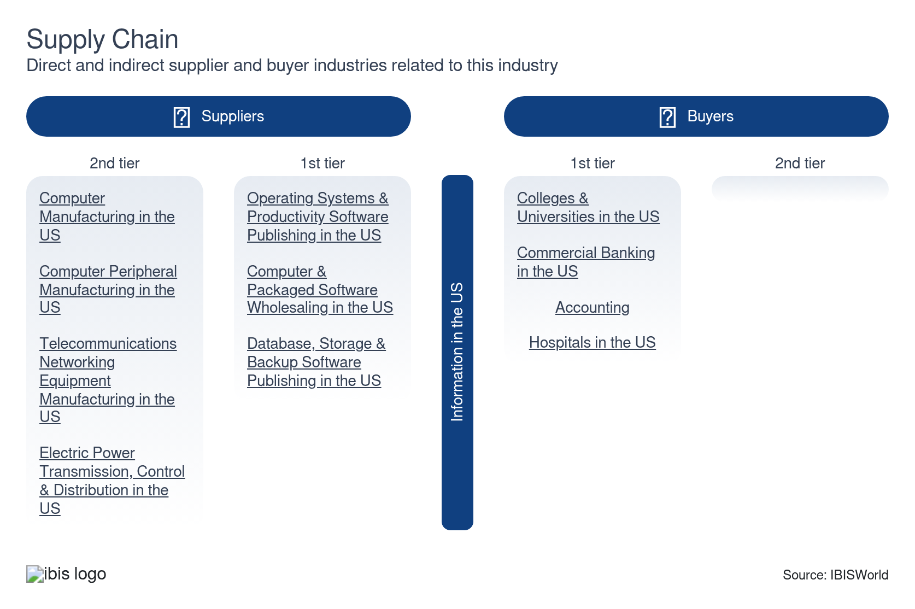

What power do buyers and suppliers have over the industry?

Buyers: price competition leads to discounting and bundled offerings
High | Steady
- In the information sector, customers have a plethora of options, from streaming services to cloud storage providers. This wide range of choices enhances their bargaining power, as they can easily switch to a competitor if they are unsatisfied with the prices or services. When consumer confidence is low, people may opt for services offered at the lowest price points. According to Pew data, US broadband adoption now covers 77% of households and users readily switch providers in search of better service, price, or content.
- Some companies within industries, like telecommunications, may offer à la carte options, attracting consumers who would otherwise not purchase packages containing services they don't need. Large enterprise buyers, who may purchase software, data analytics tools, or digital advertising, wield significant power due to the volume of their purchases. This can lead to bulk discounts and customized solutions tailored to their needs.
- Large enterprise and government customers can demand customized solutions, steep discounts and favorable terms due to their significant contract sizes. For example, federal contracts for IT services in NAICS 51 reached over $10 billion in FY 2024, giving government agencies leverage to influence pricing and service levels.

Suppliers: investing in new technologies offers long-term benefits
Moderate | Increasing
- Critical hardware and software suppliers, including chipmakers, network infrastructure firms and cloud giants, can exert pricing and delivery pressure due to their scale and market dominance. A global shortage of network semiconductors in 2024–2025 led to increased input costs across the industry. Regulatory and intellectual property dependencies empower software licensors and holders of proprietary technology. For example, cloud and data service providers may lock in clients through unique security certifications or patented technologies, while licensing constraints enforce strict compliance terms.
- The development of wireless technologies is an ongoing process. Since there is still a limited supply, suppliers may demand high prices when new products are released. To stay competitive, industry enterprises must procure the latest technologies. Many suppliers in the information sector hold exclusive rights to cutting-edge technologies and software that are not easily replicated. Rapid technological advancements mean that suppliers who lead in innovation can set higher prices due to the continuous demand for the latest features, services and security enhancements.
- Although copper wires were initially used to create the PSTN, Information sector companies will purchase less expensive fiber optics from suppliers, as they have replaced copper wires as the foundation of US consumer-fixed telecommunications networks. Telecommunication companies will also purchase other technologies, such as smaller, more efficient satellites, to reduce costs and substantially lower prices for telecommunications services.
- Labor, especially technical and creative talent, acts as a powerful supplier group. For example, according to the BLS, median software development wages exceeded $120,000 in 2025, and compensation for in-demand roles rose 3.5% year-over-year, heightening cost pressures on employers.

How do successful businesses manage buyer & supplier power?
Ability to quickly adopt new technology
By staying ahead with the latest tech, information sector companies can offer innovative solutions that differentiate them from the competition, reducing buyer power.
Close monitoring of competition
Keeping a watchful eye on rivals allows enterprises to anticipate market changes and adjust strategies accordingly, minimizing the impact of supplier demands and maintaining a competitive edge.
Effective cost controls
Managing costs efficiently allows companies to offer competitive pricing or increased value, appealing to buyers' budgets and reducing their bargaining leverage.
Secure a highly skilled workforce
A talented team ensures high-quality service and innovative solutions, elevating the company's value proposition and making it less susceptible to buyer and supplier power pressures. Several industry fields, such as publishing, rely on the quality of work of their employees.

7. Companies
https://my.ibisworld.com/us/en/industry/51/companies

Key Takeaways
- There are many companies operating in the Information sector, representing a wide range of industries. The largest companies by market share that dominate specific industries or product categories are often leaders in terms of innovation, efficiency and customer satisfaction.
- The largest companies within the Information sector take advantage of mergers and acquisitions. AT&T Inc. acquired DirecTV in 2015 and acquired Time Warner in 2018. Also, in February 2022, AT&T merged with media company Discovery Inc.

Market Share
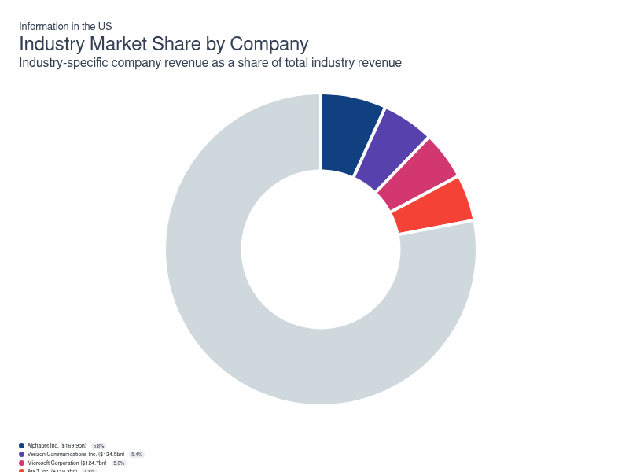
Chart displays current year only in the PDF version of this report. You can view and download chart for all other years associated with this industry on my.ibisworld.com.

Companies
Company | Market Share (%)  2025 | Revenue ($m)  2025 | Profit ($m)  2025 | Profit Margin (%)  2025
Alphabet Inc. | 6.8 | 169,923.4 | 59,055.1 | 34.8
Verizon Communications Inc. | 5.4 | 134,524.1 | 23,703.7 | 17.6
Microsoft Corporation | 5.0 | 124,704.0 | 55,673.2 | 44.6
At&T Inc. | 4.8 | 119,316.2 | 21,471.2 | 18.0
Comcast Corporation | 3.6 | 89,628.2 | 17,307.8 | 19.3
Walt Disney Co | 1.9 | 48,256.1 | 4,966.1 | 10.3

Alphabet Inc.
Alphabet Inc.
Company Details
Company Details
Industry Specific Revenue (2025) | $169.9bn
Industry Profit (2025) | $59.1bn
Company Employees (2025) | 183,323
Market Share (2025) | 6.8%

Description
Description
Alphabet is a public company headquartered in California with an estimated 183,323 employees. In the US, the company has a notable market share in at least nine industries: Information, Data Processing & Hosting Services, Search Engines, Video Conferencing Software Developers, Online Video Downloads, Music Streaming Services, Video Streaming Services, Educational Software, Hyperscale Data Center Services and Hyperscale Data Center Services. Their largest market share is in the Search Engines industry, where they account for an estimated 45.7% of total industry revenue and are considered an All Star because they display stronger market share, profit and revenue growth compared to their peers.

Other Industries
Other Industries
- Data Processing & Hosting Services in the US
- Music Streaming Services in the US
- Online Video Downloads in the US
- Search Engines in the US
- Video Conferencing Software Developers in the US
- Video Streaming Services in the US

Company’s Industry Revenue, Market Share, and Profit Margin Over Time
Company’s Industry Revenue, Market Share, and Profit Margin Over Time
Year | Industry Revenue ($ million) | Market Share (%) | Profit Margin (%)
2008 | 17610 | 1.6 | 26.3
2009 | 18539 | 1.7 | 26.3
2010 | 19357 | 1.7 | 26.3
2011 | 22069 | 1.9 | 26.3
2012 | 25423 | 2.0 | 26.3
2013 | 28819 | 2.2 | 26.3
2014 | 32756 | 2.4 | 26.3
2015 | 37149 | 2.6 | 26.3
2016 | 42428 | 2.8 | 26.3
2017 | 52102 | 3.3 | 23.6
2018 | 62937 | 3.7 | 20.1
2019 | 74843 | 4.3 | 21.1
2020 | 85014 | 4.7 | 22.6
2021 | 117854 | 5.7 | 30.6
2022 | 134814 | 6.1 | 26.5
2023 | 146286 | 6.4 | 27.4
2024 | 169923 | 7.1 | 34.8
2025 | 169923 | 6.8 | 34.8

What's impacting Alphabet Inc.'s performance?

Commitment to AI and cloud expansion
- Alphabet continues to invest heavily in artificial intelligence, enhancing its capabilities in services like Google Assistant and other AI-driven products. These investments are crucial for staying competitive in a rapidly evolving tech landscape. The company’s Waymo unit has made strides in self-driving technology, securing over $3 billion in external funding to scale operations. These investments reflect Alphabet’s ambition to enter new high-potential markets. Though these emerging technologies have not yet significantly contributed to Alphabet’s bottom line, they align with its broader strategy to ensure future revenue streams and maintain its innovation leader status.

Alphabet faces regulatory challenges and scrutiny
- Alphabet has encountered ongoing regulatory challenges, notably from the European Union, which has imposed fines exceeding $9 billion since 2017 for antitrust activities related to its Android operating system and advertising services. Heightened concerns over user data privacy have prompted new regulations in the U.S. and Europe, impacting how Google manages and monetizes data. The evolving regulatory landscape creates uncertainty and requires strategic adjustments. Alphabet has invested in legal compliance and modifications to its business practices to address these regulatory pressures, which could impact profit moving forward.
Verizon Communications Inc.
Verizon Communications Inc.
Company Details
Company Details
Industry Specific Revenue (2025) | $134.5bn
Industry Profit (2025) | $23.7bn
Company Employees (2025) | 99,600
Market Share (2025) | 5.4%

Description
Description
Verizon Communications is a public company headquartered in New York with an estimated 99,600 employees. In the US, the company has a notable market share in at least seven industries: Information, Wireless Telecommunications Carriers, Wired Telecommunications Carriers, Telecommunications Resellers, Internet Service Providers, Search Engines, Cable Providers and Search Engines. Their largest market share is in the Wired Telecommunications Carriers industry, where they account for an estimated 39.6% of total industry revenue.

Brands and Trading Names
Brands and Trading Names
- AOL
- Bluejeans Network
- FiOS
- Protectwise
- Sensity Systems
- TracFone Wireless
- Tumblr
- Verizon Wireless
- Vidder
- Yahoo!

Other Industries
Other Industries
- Cable Providers in the US
- Internet Service Providers in the US
- Search Engines in the US
- Telecommunications Resellers in the US
- Wired Telecommunications Carriers in the US
- Wireless Telecommunications Carriers in the US

Company’s Industry Revenue, Market Share, and Profit Margin Over Time
Company’s Industry Revenue, Market Share, and Profit Margin Over Time
Year | Industry Revenue ($ million) | Market Share (%) | Profit Margin (%)
2008 | 91541 | 8.2 | 23.2
2009 | 88946 | 8.2 | 23.2
2010 | 92285 | 8.2 | 23.2
2011 | 97154 | 8.2 | 23.2
2012 | 102214 | 8.2 | 23.2
2013 | 106520 | 8.2 | 23.2
2014 | 112777 | 8.2 | 23.2
2015 | 117991 | 8.2 | 23.2
2016 | 125980 | 8.2 | 23.2
2017 | 126034 | 7.9 | 21.8
2018 | 130863 | 7.8 | 17.0
2019 | 131868 | 7.5 | 23.0
2020 | 128292 | 7.1 | 22.4
2021 | 133613 | 6.5 | 24.3
2022 | 136835 | 6.2 | 22.3
2023 | 133974 | 5.9 | 17.1
2024 | 134524 | 5.6 | 17.6
2025 | 134524 | 5.4 | 17.6

What's impacting Verizon Communications Inc.'s performance?

Verizon's strategic partnerships enhance service offerings
- Verizon has formed strategic partnerships to enhance its service portfolio and boost competitiveness. Collaborations with companies like Disney and Apple have bundled services, offering customers more value and retention incentives. These partnerships have helped Verizon tap into additional customer segments by integrating popular streaming and technological services. Although beneficial, these partnerships require ongoing negotiations and adjustments to address shifting consumer preferences and maintain profitability.

Verizon’s 5G Ultra Wideband is expected to increase its coverage in 2022
- Verizon has committed over $40 billion to developing and deploying its 5G network, reflecting its intention to be a frontrunner in next-generation internet services. By the end of 2022, Verizon's 5G coverage reached over 175 million people across the United States, showcasing rapid and widespread adoption. Specifically, initiatives like the "5G Home Internet" service aim to disrupt traditional broadband markets by offering competitive speeds for home use, enhancing user experience with minimal latency. The company has also developed partnerships with technology firms to innovate 5G applications, boosting network efficiency and creating new revenue streams.

Verizon looks to acquire Frontier Communications to bolster network coverage
- In August 2024, Verizon Communications announced its plans for a $20 billion all-cash acquisition of Frontier Communication. This deal will dramatically widen Verizon's network footprint nationwide, strengthening its presence in regions with minimal or no coverage. The acquisition aims to enhance Verizon's network capacity and coverage, particularly in rural and suburban areas where Frontier had a presence.

Competitive pricing and bundled offerings attract customers
- Verizon has introduced competitive pricing models to capture a larger market share, often bundling internet services with TV and phone plans under products like “Mix & Match.” For example, a typical bundle might include Fios Gigabit Internet, a wireless phone plan and a subscription to streaming services like Disney+. These bundles are designed to offer significant cost savings and added convenience, making Verizon a compelling choice for consumers looking to simplify their billing. This strategy particularly appeals to families and households, who benefit from reduced overall costs and a more streamlined service experience, making Verizon a more compelling choice.
Microsoft Corporation
Microsoft Corporation
Company Details
Company Details
Industry Specific Revenue (2025) | $124.7bn
Industry Profit (2025) | $55.7bn
Company Employees (2025) | 228,000
Market Share (2025) | 5.0%

Description
Description
Microsoft is a public company headquartered in Washington with an estimated 228,000 employees. In the US, the company has a notable market share in at least 19 industries: Information, Software Publishing, VoIP Services, Data Processing & Hosting Services, Search Engines, Operating Systems & Productivity Software Publishing, Database, Storage & Backup Software Publishing, Business Analytics & Enterprise Software Publishing, Video Game Software Publishing, CRM System Providers, Video Conferencing Software Developers, Internet Hosting Services, Cloud Security Software, Business Intelligence Software, Virtual Reality Software Developers, Identity Management Software, Collaboration & Project Management Software, Educational Software, Hyperscale Data Center Services and Virtual Reality Software Developers. Their largest market share is in the CRM System Providers industry, where they account for an estimated 56.8% of total industry revenue.

Brands and Trading Names
Brands and Trading Names
- 343 Industries
- Ally.IO
- Bing
- Comcast
- Dynamics CRM
- Dynamics ERP
- LinkedIn
- Microsoft Azure
- Microsoft Bing
- Microsoft Edge
- Microsoft Office
- Microsoft SQL Server
- MSN
- Office 365
- Skype
- Windows 7
- Windows Server
- Windows Vista
- Windows XP
- Xbox

Other Industries
Other Industries
- Business Analytics & Enterprise Software Publishing in the US
- Business Intelligence Software in the US
- Cloud Security Software in the US
- Collaboration & Project Management Software in the US
- CRM System Providers in the US
- Data Processing & Hosting Services in the US
- Database, Storage & Backup Software Publishing in the US
- Identity Management Software in the US
- Internet Hosting Services in the US
- Operating Systems & Productivity Software Publishing in the US
- Search Engines in the US
- Software Publishing in the US
- Video Conferencing Software Developers in the US
- Video Game Software Publishing in the US
- Virtual Reality Software Developers in the US
- VoIP Services in the US

Company’s Industry Revenue, Market Share, and Profit Margin Over Time
Company’s Industry Revenue, Market Share, and Profit Margin Over Time
Year | Industry Revenue ($ million) | Market Share (%) | Profit Margin (%)
2008 | 22866 | 2.0 | 30.1
2009 | 23761 | 2.2 | 30.1
2010 | 24898 | 2.2 | 30.1
2011 | 28034 | 2.4 | 30.1
2012 | 31841 | 2.5 | 30.1
2013 | 35659 | 2.7 | 30.1
2014 | 40161 | 2.9 | 30.1
2015 | 45071 | 3.1 | 30.1
2016 | 51078 | 3.3 | 30.1
2017 | 55926 | 3.5 | 31.8
2018 | 64199 | 3.8 | 34.1
2019 | 64199 | 3.6 | 34.1
2020 | 73160 | 4.0 | 37.0
2021 | 83953 | 4.1 | 41.6
2022 | 100218 | 4.5 | 42.1
2023 | 106744 | 4.7 | 41.8
2024 | 124704 | 5.2 | 44.6
2025 | 124704 | 5.0 | 44.6

What's impacting Microsoft Corporation's performance?

Microsoft Entra ID adopted by government organizations
- As of 2024, US government agencies are increasingly integrating Microsoft Entra ID to streamline identity management, reduce operational complexity and enhance user oversight. The platform enforces multifactor authentication and enables phishing-resistant measures, while evaluating device data for secure access, aligning with federal directives to bolster cybersecurity across staff, contractors, and partners.

Microsoft recently launched new CRM features
- Microsoft announced the 2024 release of wave 2 plans for Dynamics 365 and Power Platform in July 2024. The planned improvements, scheduled from October 2024 through March 2025, have introduced new features to improve user comprehension and enhance the user experience. The update has used advanced AI and Microsoft Copilot technologies to optimize user productivity and simplify operations across various business applications. This has included smart automation, AI-driven insights and immersive user interactions, facilitating a more seamless integration of data, insights and people. Using these CRM features, Microsoft plans to bolster its market share within various industries, such as in business analytics and enterprise software.

Microsoft enhances its cloud offerings
- In 2023, Microsoft invested in enhancing its cloud-based software. During March, the company added Copilot to its Dynamics 365 platform, automating tasks and improving functions for clients. Meanwhile, Microsoft also released Azure Virtual Machines, which are powered by AMD Instinct and NVIDIA Hopper GPUs, which are designed to handle AI and high-performance computing workloads.
At&T Inc.
At&T Inc.
Company Details
Company Details
Industry Specific Revenue (2025) | $119.3bn
Industry Profit (2025) | $21.5bn
Company Employees (2025) | 149,900
Market Share (2025) | 4.8%

Description
Description
At&T is a public company headquartered in Texas with an estimated 149,900 employees. In the US, the company has a notable market share in at least seven industries: Information, Movie & Video Production, Wireless Telecommunications Carriers, Wired Telecommunications Carriers, Internet Service Providers, Satellite TV Providers, Media Streaming, Social Networks & Other Content Providers and Media Streaming, Social Networks & Other Content Providers. Their largest market share is in the Satellite TV Providers industry, where they account for an estimated 53.7% of total industry revenue.

Brands and Trading Names
Brands and Trading Names
- AppNexus
- AT&T
- AT&T Mobility
- DirecTV
- Home Box Office
- Leap Wireless
- Max
- Otter Media Holdings
- Time Warner
- U-Verse
- Warner Bros

Other Industries
Other Industries
- Internet Service Providers in the US
- Media Streaming, Social Networks & Other Content Providers in the US
- Movie & Video Production in the US
- Satellite TV Providers in the US
- Wired Telecommunications Carriers in the US
- Wireless Telecommunications Carriers in the US

Company’s Industry Revenue, Market Share, and Profit Margin Over Time
Company’s Industry Revenue, Market Share, and Profit Margin Over Time
Year | Industry Revenue ($ million) | Market Share (%) | Profit Margin (%)
2008 | 113071 | 10.1 | 14.4
2009 | 109866 | 10.1 | 14.4
2010 | 113990 | 10.1 | 14.4
2011 | 120004 | 10.1 | 14.4
2012 | 126254 | 10.1 | 14.4
2013 | 131573 | 10.1 | 14.4
2014 | 139302 | 10.1 | 14.4
2015 | 145742 | 10.1 | 14.4
2016 | 155610 | 10.1 | 14.4
2017 | 151543 | 9.5 | 12.4
2018 | 160345 | 9.5 | 15.3
2019 | 170665 | 9.7 | 16.5
2020 | 136188 | 7.5 | 20.3
2021 | 128736 | 6.3 | 21.2
2022 | 116819 | 5.3 | 24.1
2023 | 118519 | 5.2 | 19.2
2024 | 119316 | 5.0 | 18.0
2025 | 119316 | 4.8 | 18.0

What's impacting At&T Inc.'s performance?

AT&T has seen increased competition in rural US areas
- While AT&T has made significant progress in urban and suburban markets, rural regions in the US have posed more significant challenges due to the high costs of infrastructure deployment and less customer density. Competitors like SpaceX's Starlink satellite internet service and other wireless broadband providers have targeted these underserved rural areas, offering high-speed internet solutions that bypass traditional infrastructure constraints. AT&T has sought to address these challenges through partnerships with local providers and by actively participating in government initiatives and funding programs like the FCC's Rural Digital Opportunity Fund (RDOF). The RDOF aims to extend broadband services to underserved and unserved rural areas. Through RDOF, AT&T has secured funding to deploy high-speed internet to millions of rural homes and businesses across the US This commitment underscores the company’s role in federal efforts to enhance digital infrastructure.

AT&T and Frontier Communications Strike Network Deal
- In October 2021, AT&T announced it would work with Frontier Communications to bring fiber-optic connectivity to large enterprise customers outside AT&T’s current footprint. The two companies signed multi-year strategic agreements that will also support AT&T’s 5G mobility network deployment. AT&T is building out additional fiber across its wired footprint and plans to reach about 2.5 million incremental customer locations by the end of 2021 and 30 million locations by the end of 2025. AT&T’s business fiber network enables high-speed connections to over 2.5 million US business customer locations as of September 30, 2021.

Merger with Discovery and Spin-Off of Warner Media Aim to Refocus Core Operations
- In 2022, AT&T spun off WarnerMedia and merged it with Discovery, Inc. to form a new entity, Warner Bros. Discovery. This strategic move aimed to separate its media and entertainment businesses from its core telecommunications operations. The spin-off allowed AT&T to offload significant debt accumulated during its acquisition of Time Warner in 2018. Reducing this debt was crucial for stabilizing its balance sheet and freeing up resources. AT&T aimed to streamline its focus and operational efficiency by disentangling its media and telecom businesses. The move allowed AT&T to focus capital and attention on its US 5G and fiber optic networks, while the spin-off aimed to unlock shareholder value, creating distinct, focused entities in telecommunications and media/entertainment through Warner Bros. Discovery.

AT&T's gradual phasing out of landline services
- Recently, AT&T has steadily phased out its traditional landline services, aligning with broader industry moves toward digital and mobile technologies. This shift reflects the declining consumer demand for fixed-line telephones amid the popularity of mobile and internet-based communication. AT&T has encouraged customers to transition to wireless and VoIP services, which offer more flexibility and modern features than legacy landline systems. The company has reduced investments in maintaining its copper landline infrastructure, instead focusing on more profitable and technologically advanced fiber optic networks and wireless services. This strategic move aims to reduce operational costs associated with aging infrastructure while embracing digital transformation.
Comcast Corporation
Comcast Corporation
Company Details
Company Details
Industry Specific Revenue (2025) | $89.6bn
Industry Profit (2025) | $17.3bn
Company Employees (2025) | 182,000
Market Share (2025) | 3.6%

Description
Description
Comcast is a public company headquartered in Pennsylvania with an estimated 182,000 employees. In the US, the company has a notable market share in at least six industries: Information, Wired Telecommunications Carriers, Internet Service Providers, Cable Providers, Online Video Downloads, Water Parks and Water Parks. Their largest market share is in the Cable Providers industry, where they account for an estimated 15.7% of total industry revenue.

Brands and Trading Names
Brands and Trading Names
- Clean Franchise Brands
- Comcast Business
- Comcast Spectacor
- Comcast Technology Solutions
- Comcast Ventures
- NBCUniversal
- Pressed4Time
- Sky
- Xfinity

Other Industries
Other Industries
- Cable Providers in the US
- Internet Service Providers in the US
- Online Video Downloads in the US
- Water Parks in the US
- Wired Telecommunications Carriers in the US

Company’s Industry Revenue, Market Share, and Profit Margin Over Time
Company’s Industry Revenue, Market Share, and Profit Margin Over Time
Year | Industry Revenue ($ million) | Market Share (%) | Profit Margin (%)
2008 | 50621 | 4.5 | 20.8
2009 | 49186 | 4.5 | 20.8
2010 | 51033 | 4.5 | 20.8
2011 | 53725 | 4.5 | 20.8
2012 | 56523 | 4.5 | 20.8
2013 | 58905 | 4.5 | 20.8
2014 | 62365 | 4.5 | 20.8
2015 | 65248 | 4.5 | 20.8
2016 | 69666 | 4.5 | 20.8
2017 | 72301 | 4.5 | 21.2
2018 | 77288 | 4.6 | 20.1
2019 | 78221 | 4.4 | 19.4
2020 | 78703 | 4.3 | 16.9
2021 | 86980 | 4.2 | 17.9
2022 | 90452 | 4.1 | 11.6
2023 | 87430 | 3.8 | 19.2
2024 | 89628 | 3.8 | 19.3
2025 | 89628 | 3.6 | 19.3

What's impacting Comcast Corporation's performance?

Significant Investments in content and entertainment
- Comcast has considerably increased its investments in U.S.-based content and entertainment through NBCUniversal and its streaming platform, Peacock. Major initiatives included acquiring media rights, investments in original programming and partnerships with content creators to strengthen its US market presence. These investments are designed to diversify Comcast's revenue streams and capitalize on the shift toward digital content consumption.

Push for innovation in data capabilities and smart technologies
- Comcast has embraced new technologies to improve its data capabilities and smart home solutions. An example includes the rollout of the xFi Advanced Gateway, which leverages Wi-Fi 6 technology to provide faster and more reliable internet connectivity. The company also incorporates AI-driven customer service tools and develops smart home products, like its Xfinity Home security systems. These technological innovations enhance customer experiences and help Comcast diversify its offerings beyond basic internet and cable, strengthening its position in the rapidly evolving telecommunications industry.

Stagnation in traditional cable subscribers forces Comcast to adapt
- Comcast has faced a continuous decline in traditional cable TV subscribers in the US over the past five years. Comcast has strategically bundled cable services with internet and mobile offerings under the Xfinity brand to mitigate subscriber losses. The company has also enhanced its broadband services to appeal to cord-cutters, effectively shifting its focus from cable to internet services in the US.

You can view and download company details on my.ibisworld.com.

8. External Environment
https://my.ibisworld.com/us/en/industry/51/external-environment

Key Takeaways
- Despite inflation and economic challenges, total advertising expenditure is on the rise. Companies are investing more in promotional campaigns to capture a bigger slice of consumer spending.
- A surge in mobile internet connections is boosting telecom revenues and media content demand. The increasing number of mobile users represents a significant opportunity for the Information sector's expansion.
- Net neutrality is back in the spotlight. The FCC reinstated net neutrality in 2024, reigniting debates on balancing an open internet with fears of hindering broadband growth and innovation.
- Privacy rights are getting tougher. Regulations like GDPR and CCPA are putting pressure on companies to handle personal data responsibly, with hefty fines and strict rules to protect consumer privacy.

External Drivers

What demographic and macroeconomic factors impact the industry?
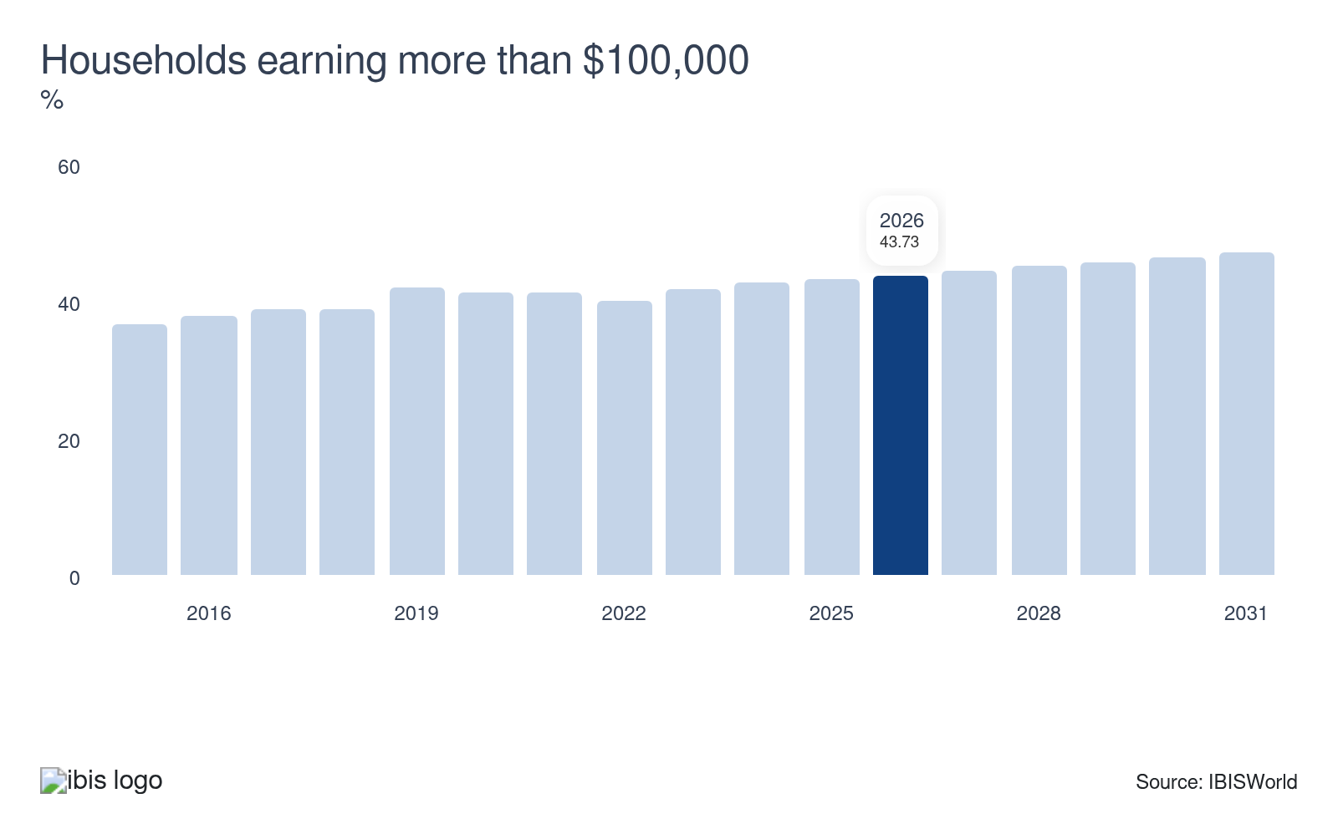
Households are the basic subscriber unit for many of the Information sector’s services and wealthier households tend to subscribe to more telecommunications services and premium content. Higher income levels strengthen demand for premium information services and digital and print subscriptions. This financial capability encourages consumer spending on media, telecommunications and data services, driving revenue growth and innovation within the sector. Overall, affluent households significantly stimulate industry expansion.
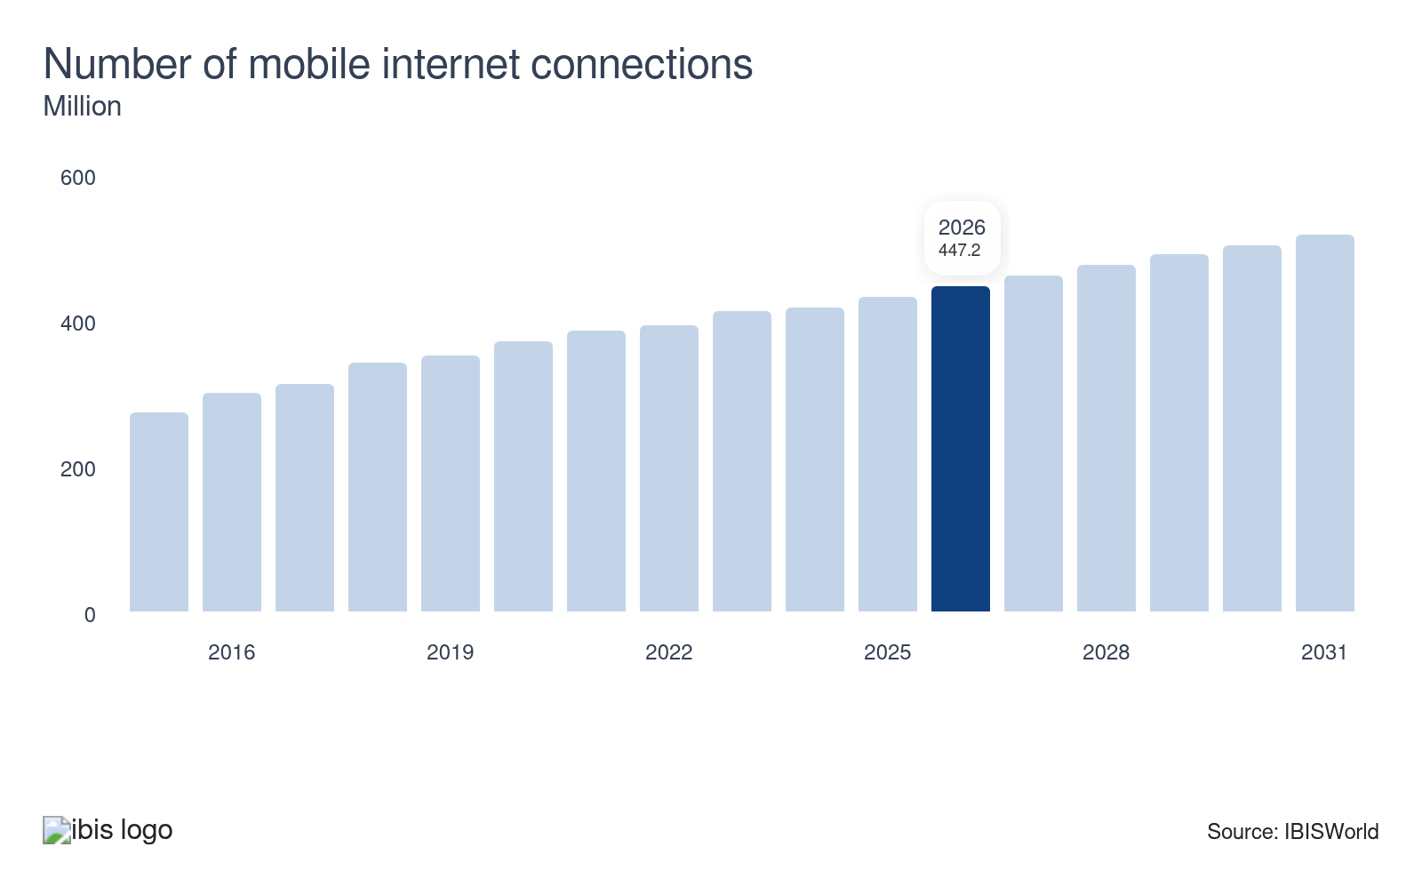
New technology has a significant impact on the information sector. For example, expanding mobile internet connections boosts telecommunications revenue while providing new ways to reach consumers with media content, pushing up demand for the Information sector. Increased mobile connectivity enables more personalized and real-time content delivery, thereby enhancing user engagement and satisfaction. Inclines in the number of mobile internet connections represent an opportunity for the Information sector.
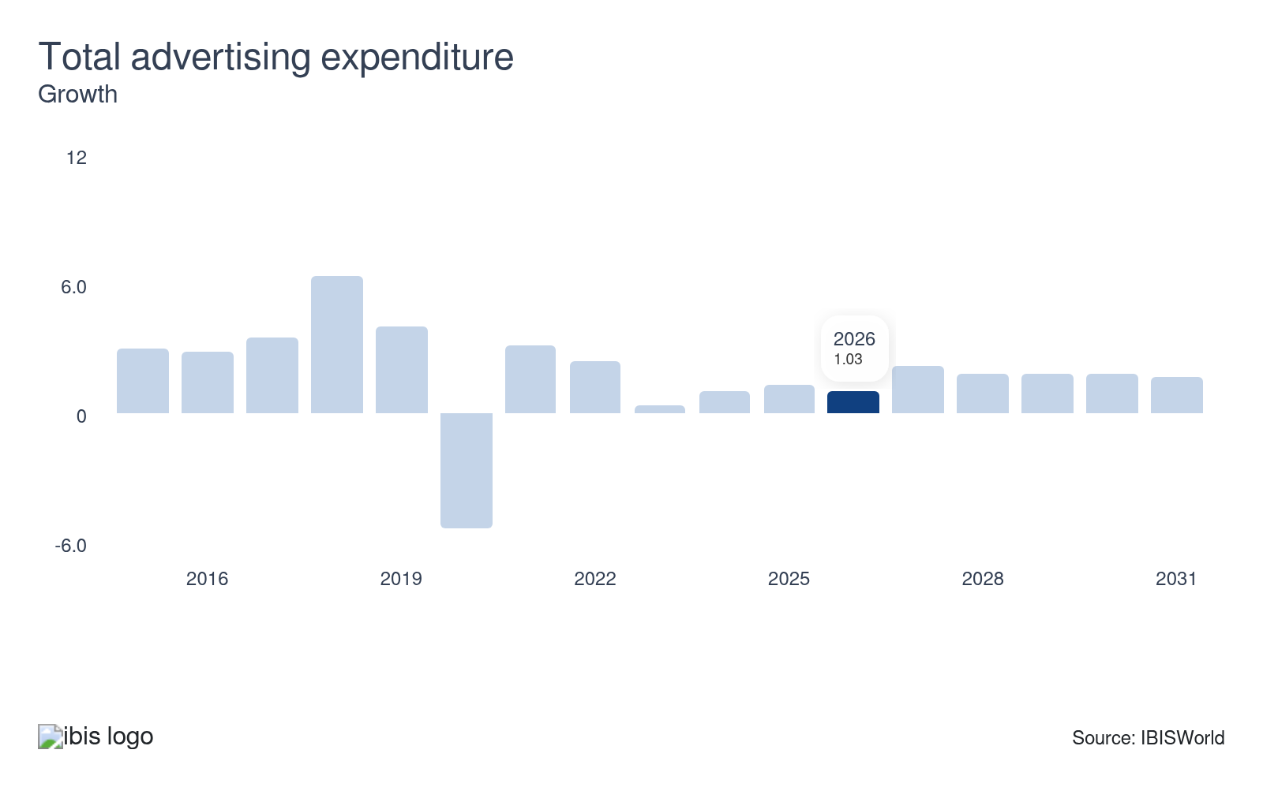
Total advertising expenditure measures the value of promotional campaigns across various US media. The Information sector generates some revenue from paid advertising and, therefore, benefits from swells in ad spending. Growth in advertising expenditure slows when consumer spending falls. Inflationary pressure can temper consumer spending and, by extension, advertising expenditure. Businesses will expand their advertising budgets and media purchases as corporate profit mounts. Increased ad spending drives higher revenue for digital platforms, media firms and content creators.
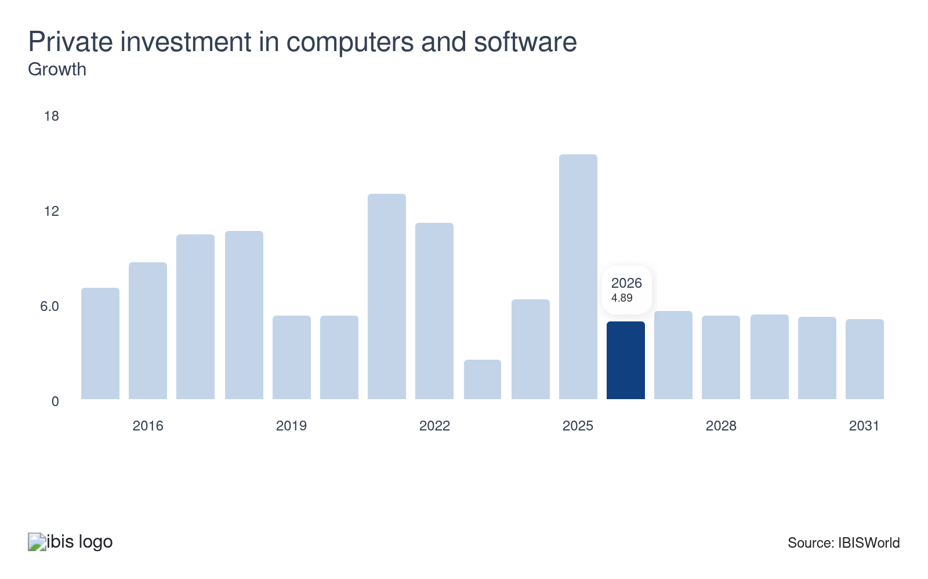
Private investment in computers and software directly determines demand for the sector's software publishing segment. Enhanced technology infrastructure enables faster data processing, improved cybersecurity and innovative digital content, driving sector growth. The accelerated use of computers and software will also lead to an increased demand for data hosting. Declines or stagnations in private investment in computers and software threaten the Information sector.

Regulation & Policy
Moderate | Decreasing

What regulations impact the industry?

Copyright, content moderation and platform liability
Federal laws, particularly Section 230 of the Communications Decency Act (CDA) and the Digital Millennium Copyright Act (DMCA), define the boundaries of responsibility for content published or transmitted by platforms and ISPs. Section 230 largely shields online service providers from legal liability for user-generated content, enabling platforms to operate on a large scale and foster user engagement without incurring significant legal risk. Meanwhile, the DMCA establishes a “safe harbor” system: platforms are protected from copyright liability if they promptly remove infringing material upon notification. Together, these regimes incentivize proactive content monitoring and robust procedures to swiftly address copyright claims. Ongoing debates about Section 230 reform and high-profile legal challenges keep this policy environment dynamic and potentially volatile for businesses.

Data privacy and consumer protection laws
Stringent data privacy laws, such as the California Consumer Privacy Act (CCPA) and the Colorado Privacy Act, as well as state-level cyber regulations, compel companies to protect user information and be transparent about their data practices. These requirements compel firms to invest in comprehensive security practices, refine their digital marketing strategies and regularly update compliance protocols. Regulations like the federal Children’s Online Privacy Protection Act (COPPA) add further layers by specifying unique safeguards and consent standards for the collection and use of children’s data. The rapidly evolving legal landscape means that firms must dedicate significant resources to monitoring, reporting and adapting to regulatory shifts or risk steep penalties and loss of consumer trust.

Federal Trade Commission (FTC) Act
The FTC Act enforces consumer protection laws to curb deceptive or unfair business practices. In the information sector, this includes ensuring truthful advertising, protecting consumer privacy and enforcing data security standards. The FTC can initiate investigations and impose penalties on companies that mislead consumers or fail to protect their personal information. Section 5 of the FTC Act prohibits deceptive or unfair business practices, including failures to protect consumer data or misleading claims about privacy and security. The FTC has recently used its authority to challenge both large-scale data breaches and instances where tech companies have diluted security (such as encryption) to comply with foreign laws, warning that such actions cannot undermine US consumer rights. For the information sector, this means maintaining transparent and robust privacy and data protection practices while carefully managing global compliance obligations.

Cybersecurity Regulations
The Cybersecurity Incident Reporting Act requires critical infrastructure operators to report cyber incidents promptly. This move aims to bolster national cyber defenses, compelling companies in the information sector to enhance their incident response strategies. The regulation seeks to improve collective cyber threat intelligence and resilience by imposing strict timelines for reporting breaches to federal agencies. Cybersecurity frameworks, such as the Federal Information Security Modernization Act (FISMA) and state-level breach notification laws, set rigorous requirements for protecting digital systems and customer data. Further, the SEC’s incident disclosure rules for public companies require swift reporting of significant cyber events. These regulations push companies to adopt advanced risk management, threat monitoring and incident response plans. Non-compliance risks can include steep fines, reputational harm, and loss of government contracts, particularly for those serving public-sector clients or managing critical infrastructure.

Net neutrality
Net neutrality refers to rules that prevent internet service providers (ISPs) from blocking or prioritizing specific online content or data flows. For years, the FCC mandated net neutrality at the federal level, but recent federal court decisions ended these requirements, shifting authority to the states. As a result, companies in the information sector may now face a fragmented landscape, with some states upholding strict neutrality and others allowing ISPs to offer paid prioritization or throttle services. This policy uncertainty can impact digital media distribution, streaming services and cloud-based businesses by favoring large content providers and increasing entry barriers for new market entrants.

Broadcasting and deceny laws
Broadcasting companies and digital media services must comply with content restrictions under laws such as the Communications Act of 1934 and the FCC’s indecency regulations. These rules restrict the airing of obscene or indecent content, particularly on radio and television, with stricter standards during hours when children are likely to be in the audience. Noncompliance can result in substantial fines and even license revocation, impacting how content creators design programs and when broadcasters schedule certain material.

Telecommunications and national security
Telecommunications providers are subject to numerous security and ownership regulations, particularly following the FCC's expansions in 2025, which prohibit foreign-controlled entities with national security ties from owning certain assets or facilities. These rules require ongoing compliance certification, more rigorous background investigations and additional reporting for telecom infrastructure providers, which can impact mergers, partnerships and access to international capital or technology.

Assistance
Low | Steady

What assistance is available to this industry?

Federal grants and research funding
US federal agencies invest substantial resources in the information sector through grants dedicated to research and technology development. These funds often target emerging fields, such as artificial intelligence, cybersecurity and advanced communications and are essential for smaller players that lack the internal resources for expensive R&D initiatives. Federal support, including direct grants, contracts, and agency-funded programs such as SBIR and STTR, not only de-risks the early stages of technological exploration but also steers innovation toward goals considered nationally strategic or in the public interest.

R&D tax credits and other funding
Tax credits serve as a powerful catalyst for innovation in the information sector, particularly for companies that invest heavily in new technologies. The US government utilizes R&D tax credits to alleviate corporate tax burdens in exchange for documented expenditures on research activities, thereby making high-risk ventures financially viable. These public incentives extend beyond income tax relief to include payroll tax waivers for smaller businesses and are sometimes augmented for enterprises engaging in qualified public-private partnerships. This infrastructure of credits and incentives helps channel private investments into transformative projects, sustaining the sector’s rapid pace of advancement.

Government contracting and procurement
Government contracts provide the information sector with reliable revenue streams and large-scale deployment opportunities. Federal, state and local agencies routinely engage information companies for services such as broadband expansion, digital content creation, secure communications and data hosting. Winning these contracts often acts as a stamp of approval, elevating a firm’s profile while also funding further development. Major legislation, such as the CHIPS Act and infrastructure bills, frequently earmarks billions to spread advanced information technologies and create new sector-specific jobs.

Local and state initiatives
Municipalities and states compete to attract information sector investment by offering tailored incentives, including property tax abatements, sales tax exemptions on technology equipment and direct support for infrastructure improvements. These incentives reduce operational costs and encourage companies to expand data centers, film studios, or broadcasting facilities in particular regions. Local incentives are especially impactful where the information sector’s physical footprint, such as movie production or data hosting, can stimulate local economies and create high-value jobs.

Newspaper Industry Associations
The News Media Alliance (NMA) and the National Newspaper Association (NNA) provide vital support to the newspaper industry. The NMA offers research, advocacy and events to connect newspaper professionals. Meanwhile, the NNA promotes awareness of community newspapers and educates the public on their value. These organizations enhance the industry's impact and sustainability by offering tailored assistance to both daily and community newspapers across the United States.

The National Search Engine Optimization Association and the Search Engine Marketing Professional Organization
The information sector benefits from substantial support from organizations such as the National Search Engine Optimization Association and the Search Engine Marketing Professional Organization. These bodies, alongside various trade organizations and consulting firms, assist advertisers in refining their search engine marketing campaigns. This support enhances campaign effectiveness, driving better results and ensuring the efficient use of marketing resources.

Wireless Internet Industry Associations
Formerly known as the Cellular Telecommunications and Internet Association, the CTIA advocates and provides research materials for wireless providers and related equipment manufacturers. The CTIA educates policymakers on innovations in wireless internet technology, like 5G networks. Fixed wireless internet service providers (WISPS) compete with larger nationwide internet service providers. These companies send wireless internet signals to homes and businesses via cell towers, rather than using at-home routers. WISPA provides advocacy and research to support the typically small companies in this market.

Magazine Industry Associations
The Association of Magazine Media (MPA) and the American Society of Magazine Editors (ASME) provide substantial support to the information sector. Established in 1919, the MPA advocates for magazine publishers through public policy efforts, including opposing postal rate hikes and implementing marketing campaigns. ASME, founded in 1963, focuses on maintaining journalistic integrity and protecting First Amendment rights, sponsoring the National Magazine Awards to recognize excellence. Both organizations support industry professionals through advocacy, events and guidelines.

Film and Television Industry Associations
Several industry associations support television producers, including the Alliance of Motion Picture and Television Producers (AMPTP). The Alliance of Motion Picture and Television Producers (AMPTP) represents over 350 industry enterprises, providing crucial support for television producers. This organization facilitates negotiations with trade unions, streamlining labor relations and securing favorable terms. By maintaining such extensive representation, the AMPTP significantly impacts the industry's operational dynamics and labor agreements, facilitating smoother production processes.

Accelerators, Incubators and Venture Capital
Incubators and accelerators provide startups with mentorship, workspace, and sometimes funding over a set period. These programs are essential, offering networking opportunities, business expertise and support from seasoned entrepreneurs, which accelerates the growth and success rates of burgeoning companies in the information sector. Venture capital plays an indispensable role in scaling high-growth companies across publishing, software and digital services. VC firms and private equity infuse startups with the capital needed to accelerate R&D and seize emerging market opportunities. Their investments enable the swift commercialization of breakthroughs with broad economic impact. Google and Netflix both benefited from significant venture capital in their formative years. This active private support is especially crucial at the commercialization stage, when technologies have moved beyond initial prototypes but need resources to scale nationally or globally.

9. Financial Benchmarks
https://my.ibisworld.com/us/en/industry/51/financial-benchmarks
Profit Margin  12.6 %  ↓ Lower than sector | Average Wage  $142k  ↑ Higher than sector | Largest Cost  Other Costs  45.1% of Revenue

Key Takeaways
- Software publishers have the highest profit because once a product is developed, there is little marginal cost in reproducing and distributing it. Print publishers operate with lower profit since drops in print advertising expenditure have pushed down audience value.
- Depreciation expenses range very widely between sector industries, depending on equipment needs. Publishing industries, whether print, internet content or software, have the lowest depreciation costs, while telecommunications providers have the highest.
- Wages in the information sector are climbing. High demand for specialized roles in AI and machine learning is pushing companies to offer hefty salaries and bonuses. This trend is intensifying competition for top talent and inflating wage costs.

Cost Structure
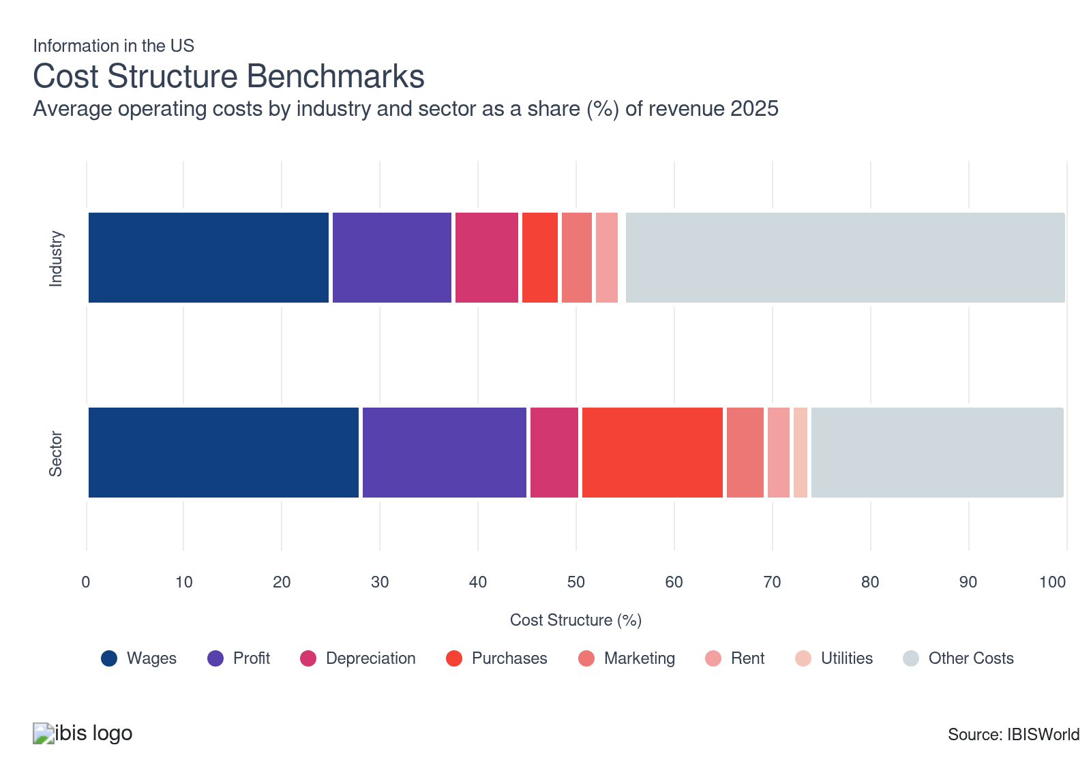
Chart displays current year only in the PDF version of this report. You can view and download chart for all other years associated with this industry on my.ibisworld.com.

What trends impact industry costs?

Wages encompass the largest expense and are growing
- The sector encompasses a significant amount of intellectual property development, including film and TV productions, as well as new software applications. Computer-related occupations are among the fastest-growing areas of employment in the sector and tend to command increasingly large wages. Telecommunications (NAICS 517) alone comprised over half of the sector’s workforce and accounted for the largest share of capital outlays.
- The sector's average wage has edged upward in recent years, while sales, installation, maintenance and administrative positions have dropped as a share of sector employment, as these tasks have undergone increased automation. Based on data from the BLS, compensation costs in the private information sector increased by 3.5% during the twelve months ending June 2025, outpacing broader inflation trends.
- The integration of AI and machine learning in industries such as telecommunications, publishing and visual media has created a high demand for specialized roles, including data scientists, machine learning engineers and data analysts. Companies offer significantly higher salaries to attract and retain top-tier talent skilled in AI technologies, sometimes including lucrative sign-on bonuses and stock options. The rapid pace of technology adoption has outpaced the supply of qualified professionals, resulting in intense competition among companies and driving up wages across the board.
- Compensation also varies by role. According to data from the BLS, telecommunications equipment installers and repairers typically earn a median hourly wage of $30.92, with an annual median pay of nearly $64,320. In contrast, information sector wages overall range from around $23 to $ 26 per hour for median and mean occupational averages. Benefits and employer-paid compensation in the industry increased 3.5% year-over-year in 2025, outpacing general inflation and reflecting the sector’s demand for skilled technical and creative talent.

Profit varies across more concentrated industries
- Software publishing industries tend to have the highest margins since once a product is developed, it costs very little to reproduce and distribute it. Operating systems and productivity software publishing is the most profitable industry in this subsector.
- Print publishers, including newspaper publishers, operate with some of the lowest profit, since drops in print advertising expenditure have pushed down audience value. Input cost hikes can also influence profitability, especially in industries where rising expenses cannot be passed downstream.
- Regarding publishing industries, devices like Kindles and smartphones make e-books easily accessible and often priced lower than print materials, making them an attractive option for cost-conscious readers. Digital substitutes have increasingly bypassed traditional publishers, disrupting their market share.
- In the telecommunications industry, consumers' shifting priorities toward data and internet packages over voice plans have led to a decline in high-margin voice service revenue, squeezing telecom profitability.
- Forbes reports that multi-channel TV penetration fell from approximately 90% of homes in 2011 to around 61% by 2023, resulting in slashed subscriber fees and advertising income that once carried healthy margins. Simultaneously, streaming platforms face intense price competition and skyrocketing content costs, leaving many services unprofitable despite growing subscriber numbers and increasing fees.

Cloud shift from hardware-heavy assets to software and services lightens depreciation
- Over the past five years, information firms have shifted aggressively from owning servers and on-premise hardware to renting cloud capacity, which depreciates on providers’ balance sheets instead of their own.
- The National Science Foundation reports that more than 80% of information-sector businesses now use cloud computing, sharply reducing their need for rapidly obsolescing physical IT assets.​
- BEA data classifies software and other intellectual property products as longer-lived assets, which spreads depreciation over more years and lowers annual capital consumption relative to short-lived equipment.

Data privacy concerns are adding expenses to the industry
- This cost segment includes any goods or services purchased by Information sector operators (except for depreciable assets) that are used directly in providing the services they offer. Purchases range widely between industries in the Information sector.
- Often, this segment represents revenue transferred between industries in the sector. For example, a cable TV provider will purchase licenses from cable networks to distribute their programming.
- New data privacy laws, such as GDPR and CCPA, have led companies to invest heavily in compliance. This shift requires updated software, specialized legal expertise and comprehensive employee training.
- Compliance-related expenses get passed down the supply chain, raising costs for information sector purchases. As privacy laws tighten globally and consumer awareness heightens demand for privacy, this will prompt organizations to enhance data security, further driving up costs.

Marketing fluctuates based on the specific industry within the Information sector
- The Information sector spends a substantial amount on advertising because it generates a significant amount of revenue from selling advertising, which requires building a marketable audience through the promotion of a publication or network.
- Advertising expenses are very high in the telecommunications industry, the most extensive information subsector, which focuses on boosting per-subscriber revenue through bundled services, thereby justifying the high customer acquisition costs.
- Companies heavily invest in advanced data analytics tools and software to analyze consumer behavior, resulting in higher upfront and ongoing costs. To derive actionable insights, businesses must integrate data from multiple sources, which necessitates the use of sophisticated platforms and increases implementation expenses.
- Developing tailored marketing strategies based on precise data insights requires dedicated resources, which can increase operational costs as campaigns become more complex and targeted.

AI-fueled data center boom pushes up specialized rent costs nationwide
- Landlords now treat racks and kilowatts like prime office floors. According to CBRE, average North American data center asking rents increased by 20–54% across key markets in just eight months, as demand outpaced available capacity.
- Colocation pricing in primary US markets has climbed, directly pressuring rent costs for NAICS 51 firms that rely on third-party facilities rather than owning their own infrastructure.

Data centers surge electricity costs across the sector
- AI-driven data centers have spiked utility expenses for US information companies. According to Pew data, in the PJM grid, which serves data center hubs like Virginia and Ohio, residential bills are expected to increase by $16–$18 monthly by 2025, adding $9.3 billion to capacity costs as firms shoulder infrastructure upgrades.
- This trend has forced sector leaders, such as Microsoft, to commit billions to renewables, yet legacy systems still inflate operational costs amid grid strains from a projected 90% demand growth by the end of the decade.

AI and cloud competition push R&D spending to new heights
- Fierce competition in AI, cloud and data services has compelled information-sector enterprises to view R&D as a strategic arms race, rather than a discretionary expense.
- According to data from the National Science Board, in 2022, the information industry (including software publishing) accounted for approximately 25–26% of all US business R&D, roughly one-quarter of a $692–$691.5 billion national R&D budget, making it the single largest non-manufacturing contributor.
- The rapid rise of AI as a critical and emerging technology also drives costs. The NSB reports, information services account for 43% of all AI-related business R&D, reflecting heavy, ongoing investment in models, infrastructure and specialized talent.
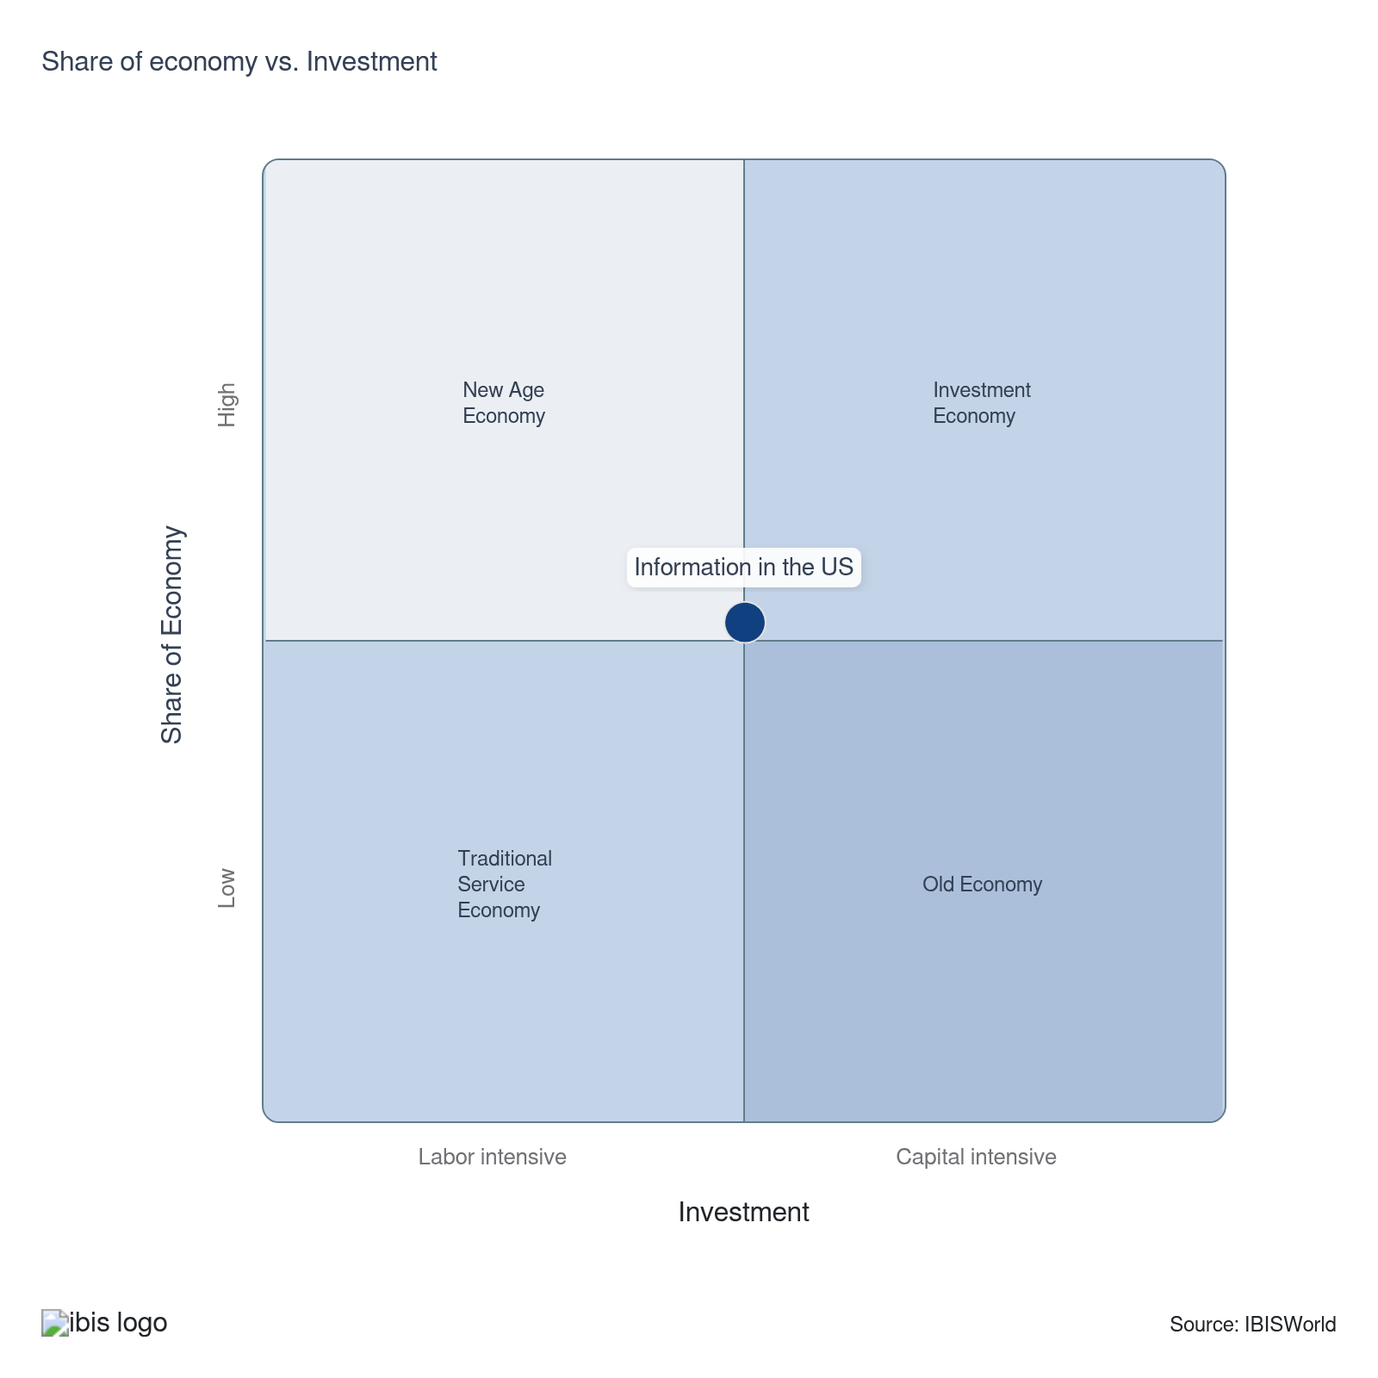

Key Ratios
Year | Revenue per Employee  ($) | Revenue per Enterprise  ($ Million) | Employees per Estab.  (Units) | Employees per Enterprise  (Units) | Average Wage  ($) | Wages/ Revenue  (%) | Estab. per Enterprise  (Units) | IVA/ Revenue  (%)
2005 | 421,749 | 4.3 | 8.5 | 10.1 | 87,353 | 20.7 | 1.2 | 40.9
2006 | 426,177 | 4.0 | 8.1 | 9.5 | 88,499 | 20.8 | 1.2 | 40.6
2007 | 433,963 | 4.2 | 8.2 | 9.7 | 90,285 | 20.8 | 1.2 | 41.4
2008 | 435,970 | 4.3 | 8.4 | 9.9 | 91,892 | 21.1 | 1.2 | 42.0
2009 | 438,242 | 4.2 | 8.1 | 9.5 | 91,536 | 20.9 | 1.2 | 41.5
2010 | 470,033 | 4.2 | 7.7 | 9.0 | 94,162 | 20.0 | 1.2 | 41.2
2011 | 484,287 | 4.3 | 7.6 | 8.9 | 96,285 | 19.9 | 1.2 | 42.8
2012 | 496,622 | 4.3 | 7.5 | 8.7 | 102,376 | 20.6 | 1.2 | 42.6
2013 | 490,238 | 4.4 | 7.8 | 9.0 | 103,864 | 21.2 | 1.2 | 42.7
2014 | 495,581 | 4.5 | 7.9 | 9.1 | 106,709 | 21.5 | 1.2 | 42.1
2015 | 509,358 | 4.7 | 7.9 | 9.2 | 110,422 | 21.7 | 1.2 | 42.6
2016 | 529,823 | 4.9 | 7.8 | 9.2 | 110,390 | 20.8 | 1.2 | 38.8
2017 | 530,243 | 4.8 | 7.7 | 9.0 | 119,591 | 22.6 | 1.2 | 43.8
2018 | 534,314 | 4.8 | 7.7 | 9.0 | 122,969 | 23.0 | 1.2 | 45.2
2019 | 551,206 | 4.9 | 7.5 | 8.8 | 126,932 | 23.0 | 1.2 | 43.6
2020 | 564,048 | 5.3 | 7.9 | 9.3 | 137,824 | 24.4 | 1.2 | 44.3
2021 | 627,801 | 5.0 | 6.9 | 8.0 | 156,039 | 24.9 | 1.2 | 44.4
2022 | 594,316 | 4.9 | 7.2 | 8.3 | 140,146 | 23.6 | 1.1 | 43.6
2023 | 568,777 | 4.9 | 7.5 | 8.6 | 141,593 | 24.9 | 1.1 | 44.1
2024 | 568,969 | 4.9 | 7.5 | 8.6 | 141,603 | 24.9 | 1.1 | 44.2
2025 | 569,612 | 4.9 | 7.5 | 8.6 | 141,638 | 24.9 | 1.1 | 44.2
2026 | 570,031 | 4.9 | 7.5 | 8.6 | 141,658 | 24.9 | 1.1 | 44.2
2027 | 571,636 | 4.9 | 7.5 | 8.6 | 141,738 | 24.8 | 1.1 | 44.2
2028 | 571,581 | 4.9 | 7.5 | 8.5 | 141,735 | 24.8 | 1.1 | 44.2
2029 | 571,415 | 4.9 | 7.5 | 8.6 | 141,727 | 24.8 | 1.1 | 44.2
2030 | 571,701 | 4.9 | 7.5 | 8.6 | 141,741 | 24.8 | 1.1 | 44.1
2031 | 572,210 | 4.9 | 7.5 | 8.6 | 141,767 | 24.8 | 1.1 | 44.2
*Figures are inflation adjusted to 2025
*Figures are inflation adjusted to 2025

10. Key Statistics
https://my.ibisworld.com/us/en/industry/51/key-statistics

Industry Data

Values
Year | Revenue  ($ Million) | IVA  ($ Million) | Estab.  (Units) | Enterprises  (Units) | Employment  (Units) | Wages  ($ Million)
2005 | 1,557,764.8 | 637,859.0 | 432,272 | 366,243 | 3,693,581 | 322,643.8
2006 | 1,582,796.2 | 642,062.5 | 459,640 | 392,647 | 3,713,941 | 328,679.0
2007 | 1,608,463.0 | 665,505.1 | 450,922 | 382,829 | 3,706,456 | 334,636.1
2008 | 1,630,801.2 | 685,745.2 | 447,943 | 379,138 | 3,740,623 | 343,731.8
2009 | 1,575,150.9 | 654,411.8 | 441,869 | 376,780 | 3,594,252 | 329,001.7
2010 | 1,614,639.0 | 665,765.0 | 446,558 | 381,233 | 3,435,163 | 323,461.6
2011 | 1,665,519.8 | 712,539.2 | 452,255 | 387,242 | 3,439,120 | 331,135.1
2012 | 1,720,209.0 | 733,058.5 | 462,980 | 398,903 | 3,463,820 | 354,612.5
2013 | 1,761,234.0 | 751,808.6 | 462,153 | 398,446 | 3,592,610 | 373,143.3
2014 | 1,831,464.9 | 771,636.3 | 469,408 | 404,249 | 3,695,591 | 394,354.7
2015 | 1,896,499.8 | 807,504.7 | 468,503 | 403,195 | 3,723,312 | 411,136.2
2016 | 2,005,458.0 | 778,825.4 | 483,601 | 412,960 | 3,785,144 | 417,842.9
2017 | 2,045,609.4 | 895,034.7 | 503,839 | 429,567 | 3,857,871 | 461,365.5
2018 | 2,115,566.8 | 956,541.0 | 516,271 | 440,746 | 3,959,405 | 486,885.2
2019 | 2,169,533.7 | 946,092.4 | 522,885 | 446,623 | 3,935,977 | 499,602.3
2020 | 2,206,657.5 | 977,509.8 | 495,647 | 419,100 | 3,912,177 | 539,190.0
2021 | 2,387,042.1 | 1,058,918.2 | 549,604 | 475,725 | 3,802,227 | 593,294.7
2022 | 2,395,255.2 | 1,045,437.5 | 557,206 | 485,592 | 4,030,272 | 564,825.7
2023 | 2,393,698.5 | 1,055,633.2 | 560,144 | 489,270 | 4,208,499 | 595,893.9
2024 | 2,439,571.0 | 1,077,351.0 | 571,888 | 499,770 | 4,287,705 | 607,153.1
2025 | 2,489,608.7 | 1,100,296.5 | 583,160 | 509,797 | 4,370,708 | 619,056.4
2026 | 2,535,421.3 | 1,121,299.3 | 593,919 | 519,402 | 4,447,867 | 630,077.7
2027 | 2,605,118.7 | 1,151,258.0 | 607,322 | 531,155 | 4,557,301 | 645,943.6
2028 | 2,669,978.5 | 1,179,226.8 | 624,284 | 546,376 | 4,671,218 | 662,077.1
2029 | 2,735,878.7 | 1,208,025.7 | 637,335 | 557,749 | 4,787,904 | 678,576.2
2030 | 2,802,834.8 | 1,237,375.1 | 650,993 | 569,622 | 4,902,620 | 694,904.3
2031 | 2,872,265.8 | 1,268,176.9 | 665,923 | 582,630 | 5,019,598 | 711,611.6

*Figures are inflation adjusted to 2025

Annual Change
Year | Revenue  % | IVA  % | Estab.  % | Enterprises  % | Employment  % | Wages  %
2005 | N/A | N/A | N/A | N/A | N/A | N/A
2006 | 1.6 | 0.7 | 6.3 | 7.2 | 0.6 | 1.9
2007 | 1.6 | 3.7 | -1.9 | -2.5 | -0.2 | 1.8
2008 | 1.4 | 3.0 | -0.7 | -1.0 | 0.9 | 2.7
2009 | -3.4 | -4.6 | -1.4 | -0.6 | -3.9 | -4.3
2010 | 2.5 | 1.7 | 1.1 | 1.2 | -4.4 | -1.7
2011 | 3.2 | 7.0 | 1.3 | 1.6 | 0.1 | 2.4
2012 | 3.3 | 2.9 | 2.4 | 3.0 | 0.7 | 7.1
2013 | 2.4 | 2.6 | -0.2 | -0.1 | 3.7 | 5.2
2014 | 4.0 | 2.6 | 1.6 | 1.5 | 2.9 | 5.7
2015 | 3.6 | 4.6 | -0.2 | -0.3 | 0.8 | 4.3
2016 | 5.7 | -3.6 | 3.2 | 2.4 | 1.7 | 1.6
2017 | 2.0 | 14.9 | 4.2 | 4.0 | 1.9 | 10.4
2018 | 3.4 | 6.9 | 2.5 | 2.6 | 2.6 | 5.5
2019 | 2.6 | -1.1 | 1.3 | 1.3 | -0.6 | 2.6
2020 | 1.7 | 3.3 | -5.2 | -6.2 | -0.6 | 7.9
2021 | 8.2 | 8.3 | 10.9 | 13.5 | -2.8 | 10.0
2022 | 0.3 | -1.3 | 1.4 | 2.1 | 6.0 | -4.8
2023 | -0.1 | 1.0 | 0.5 | 0.8 | 4.4 | 5.5
2024 | 1.9 | 2.1 | 2.1 | 2.1 | 1.9 | 1.9
2025 | 2.1 | 2.1 | 2.0 | 2.0 | 1.9 | 2.0
2026 | 1.8 | 1.9 | 1.8 | 1.9 | 1.8 | 1.8
2027 | 2.7 | 2.7 | 2.3 | 2.3 | 2.5 | 2.5
2028 | 2.5 | 2.4 | 2.8 | 2.9 | 2.5 | 2.5
2029 | 2.5 | 2.4 | 2.1 | 2.1 | 2.5 | 2.5
2030 | 2.4 | 2.4 | 2.1 | 2.1 | 2.4 | 2.4
2031 | 2.5 | 2.5 | 2.3 | 2.3 | 2.4 | 2.4

*Figures are inflation adjusted to 2025

DISCLAIMER
This product has been supplied by IBISWorld Inc. (‘IBISWorld’) solely for use by its authorized licenses strictly in accordance with their license agreements with IBISWorld. IBISWorld makes no representation to any other person with regard to the completeness or accuracy of the data or information contained herein, and it accepts no responsibility and disclaims all liability (save for liability which cannot be lawfully disclaimed) for loss or damage whatsoever suffered or incurred by any other person resulting from the use of, or reliance upon, the data or information contained herein. Copyright in this publication is owned by IBISWorld Inc. The publication is sold on the basis that the purchaser agrees not to copy the material contained within it for other than the purchasers own purposes. In the event that the purchaser uses or quotes from the material in this publication – in papers, reports, or opinions prepared for any other person – it is agreed that it will be sourced to: IBISWorld Inc.

